Name ____________________________________________________ Due Date ____________
“Waste Management” Review Packet
Digestion, Excretion and the Skin

A. Nutrition
- Define nutrition: __________________________________________________________________________________________________________________________________________________________________________________________________________________________________
- Organisms that synthesize their own food are called ______________________________ or ______________________________
- Organisms that must consume other organisms to obtain nutrition are called ________________________ or ______________________________
- Briefly explain the difference between Phototrophs and Chemotrophs :
__________________________________________________________________________________________________________________________________________________________________________________________________________________________________

B. Simple organisms
- Classify as either, autotrophic or heterotrophic

- Amoeba ________________________________
- Paramecium________________________________
- Euglena _______________________________
- Algae _______________________________

- The amoeba uses its false feet or __________________________________ to engulf food
- This process of taking food in is called _______________________________ and is a type of active transport
- The opening for ingestion in the paramecium is called the _________________________________
- The paramecium uses its ______________________ to move and swim from place to place
- Why is the euglena able to carry out autotrophic nutrition? _________________________________________________________________________________________________________________
- Draw the process of phagocytosis below and label the following: ingestion, digestion, absorption, egestion, pseudopods, food vacuole, lysosome, digestive enzymes

- The process by which organisms get rid of indigestible material is called ________________________
C. Types of Digestion
- Digestion that occurs within the cell in food vacuoles is called ______________________________________
- Digestion that occurs within a digestive cavity is called _______________________________________
- The breakdown of food into smaller pieces is called ________________________ digestion
- The breakdown of food with the use of enzymes into smaller molecules is called _________________________ digestion

- Explain why mechanical digestion is necessary to facilitate more efficient chemical digestion
__________________________________________________________________________________________________________________________________________________________________________________________________________________________________

D. Human Digestion
- The salivary glands produce a mixture called __________________________. It contains an enzyme that breaks down starch called ________________________. This means that mechanical and _____________________________ digestion of starch begins in the mouth.

- ________________________________ is the secretion produced by the stomach. It consists of _________________________ acid and ______________________. The digestion of _______________________ begins in the stomach

- Describe the function of acid in the stomach
__________________________________________________________________________________________________________________________________________________________________________________________________________________________________

- ______________________________ is the secretion produced by the liver that is temporarily stored in the _____________________ and then released into the __________________________ where is breaks down lipids ____________________________________. This is also known as _______________________________

- ______________________________ is the secretion produced by the pancreas. It contains three enzymes. _______________________ digests starch, _______________________ which digest protein and ___________________ which digests lipids. All of these are produced by the pancreas but are releases into the _______________________ where they complete chemical digestion.

- __________________________ is produced by the small intestine. This secretion contains two enzymes _____________________ which digests maltose into glucose and _____________________ which digests dipeptides into amino acids.

- The fingerlike projections that increase surface area in the small intestine allowing for maximum absorption are called ________________________________

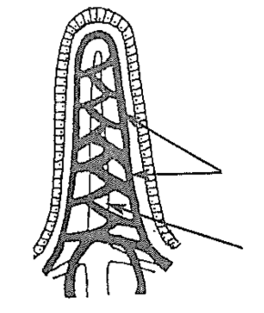
- Label the diagram of the villus:

- Which digestive end products are absorbed where?
- ________________________________ absorbs ____________________________ and ____________________________
- ________________________________ absorbs ________________________________

- Why is the length of the small intestine an important adaptation in efficient chemical digestion and absorption?____________________________________________________________________________________________________________________________________________________________________________________________________________________

- Describe the following and give an example of where it happens in a human
- Ingestion _____________________________________________________________________________________________________
- Digestion______________________________________________________________________________________________________
- Absorption ___________________________________________________________________________________________________
- Egestion ______________________________________________________________________________________________________

- List the 6 nutrients necessary in the human diet
______________________________ ______________________________ ______________________________
______________________________ ______________________________ ______________________________

- Indigestible material in food is called ____________________________________
- The rhythmic muscular contractions that move food through the digestive system is called ____________________________________
- Another name for the human digestive system is __________________________________________________
- Is digestion in human intracellular or extracellular, why?
__________________________________________________________________________________________________________________________________________________________________________________________________________________________________
- Which organs are considered accessory organs in the human digestive system
_________________________________________________________________________________________________________________
- Why are they called this? _________________________________________________________________________________________________________________

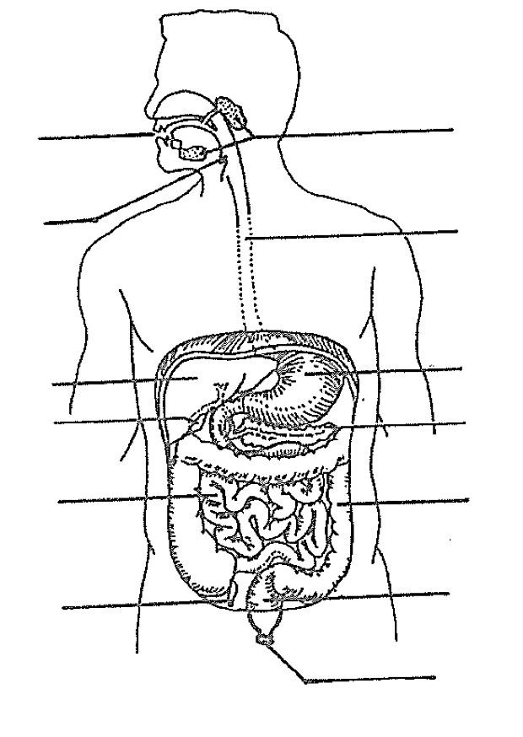

- Briefly give a function for each digestive organ
Mouth _________________________________________________________________________________________________________________
Salivary glands _______________________________________________________________________________________________________
Esophagus ____________________________________________________________________________________________________________
Epiglottis _____________________________________________________________________________________________________________
Stomach ______________________________________________________________________________________________________________
Liver __________________________________________________________________________________________________________________
Pancreas ______________________________________________________________________________________________________________
Gallbladder ___________________________________________________________________________________________________________
Small Intestine _______________________________________________________________________________________________________
Large Intestine________________________________________________________________________________________________________
Rectum _______________________________________________________________________________________________________________
Anus __________________________________________________________________________________________________________________
E. Excretion
- What metabolic wastes are made from the following metabolic processes?
Process | Waste
Cellular respiration
Protein digestion
Dehydration synthesis
Neutralization

- What are the 4 major organs of the excretory system and what are they responsible for excreting?
Organ | Waste

- Label the Skin Diagram:
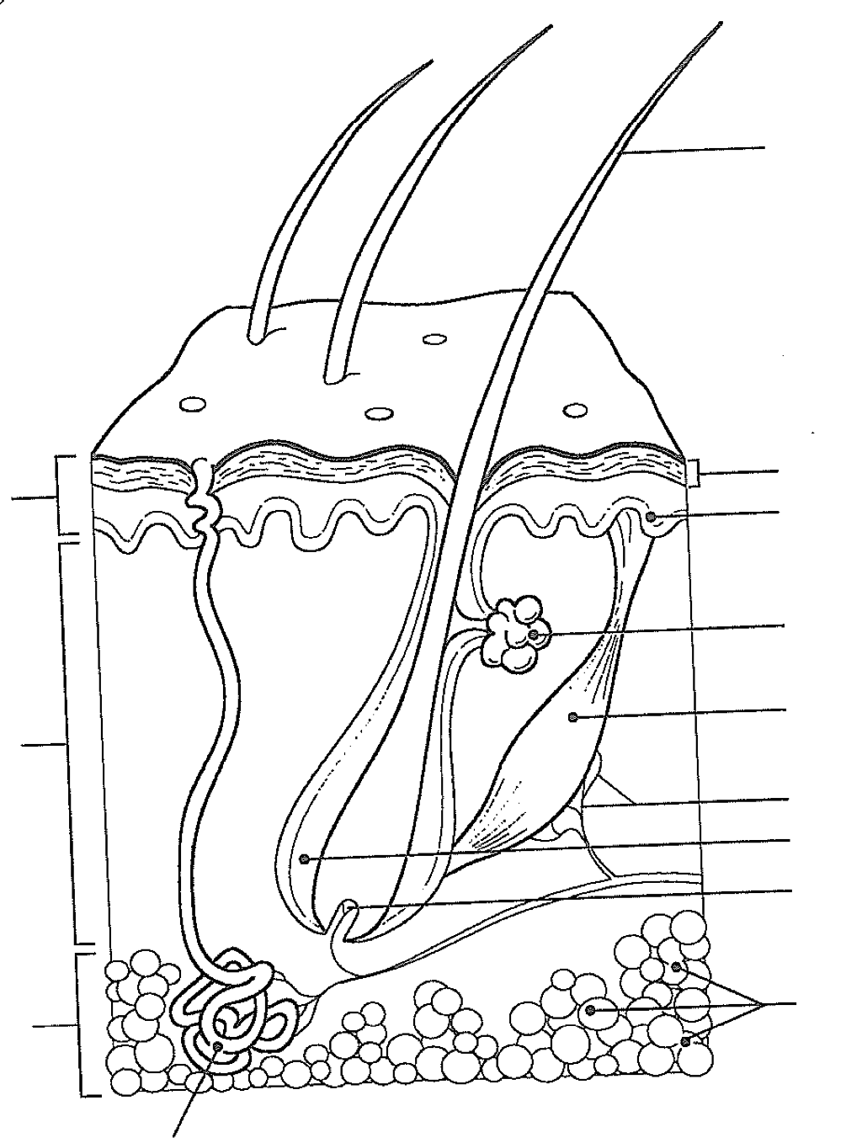

- What is the functional unit of the kidney? ______________________________
- Which substances never leave the blood in the kidneys _________________________________________________
- Which substances are removed and then reabsorbed? ___________________________________________________
- Which substances are removed and excreted? ____________________________________________________________
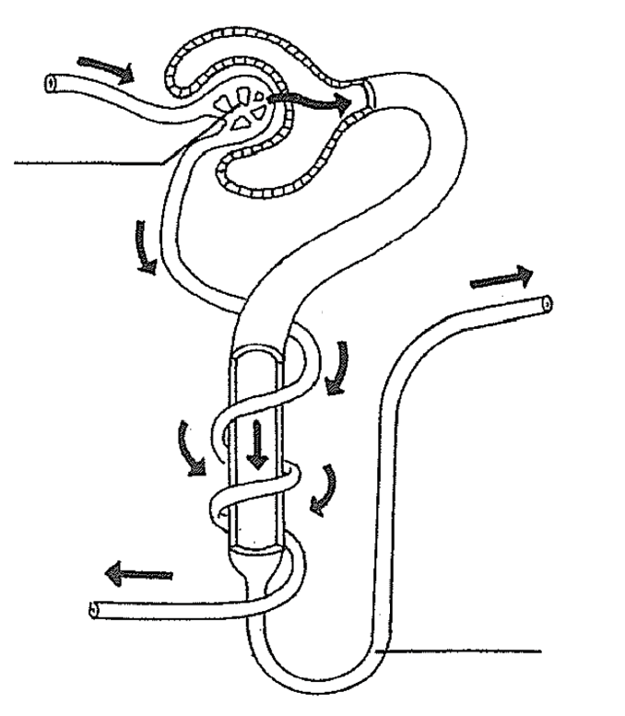
Label the following:
- Glomerulus
- Bowman’s capsule
- Loop of henle
- Capillary
- “Dirty blood”
- “Clean blood”
- Urine
- Passive transport
- Active transport
- Renal tubule

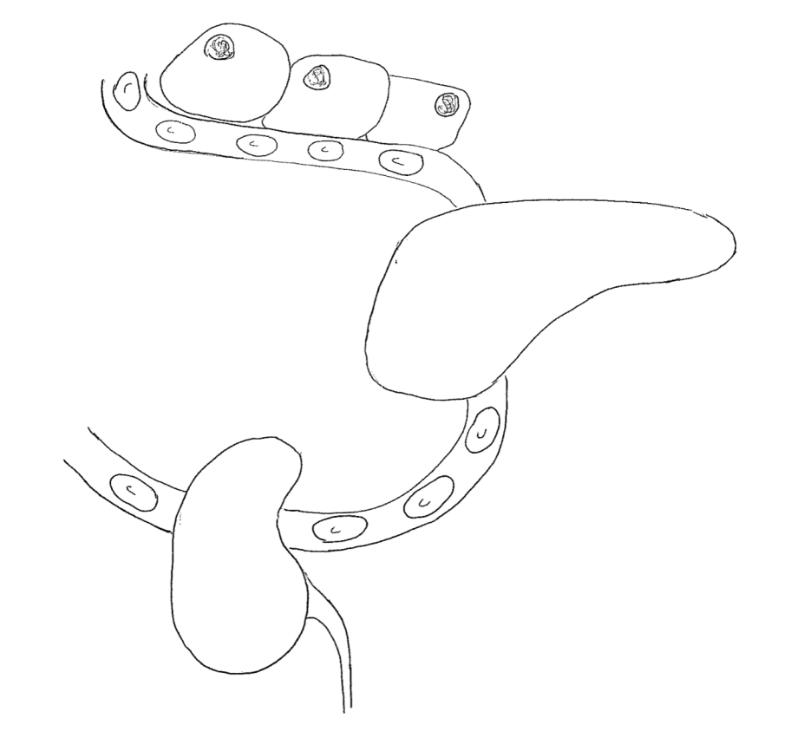

Label the following:
- Body cells
- Red blood cells
- Capillary
- Liver
- Kidney
- Ammonia rich blood
- Urea rich blood
- Clean blood
- Ureter
- NH₃ urea

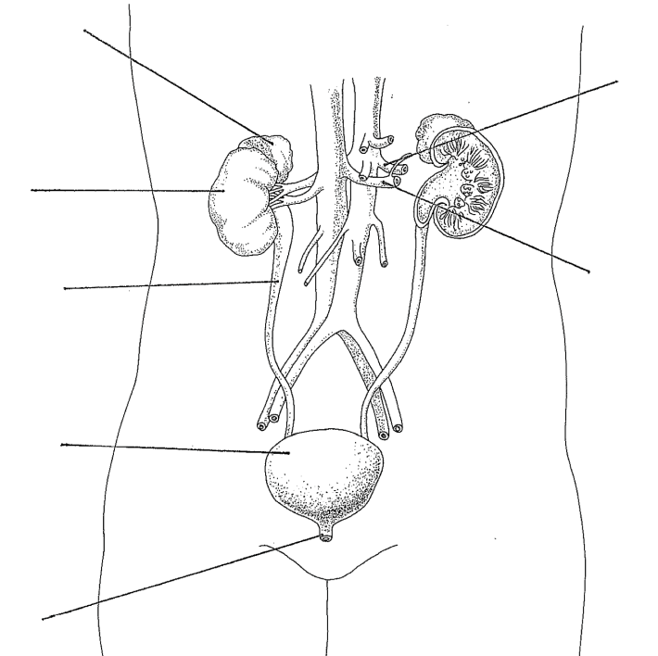
Label the following:
- Bladder
- Ureter
- Urethra
- Kidneys
- Adrenal Glands
- Aorta
- Inferior vena cava

Explain how ALL organisms excrete but not all organisms egest.
___________________________________________________________________________________________________________________________________________________________________________________________________________________________________________________________________________________________________________________________________________________________________________

