Energetics Cheat Sheet
Autotroph-producer- makes own food through photosynthesis
Heterotroph-consumer- consumes others for food

All energy come from the sun, it is just transformed to a more usual form, found in bonds
Chemical bonds store energy, breaking these bonds releases energy that can be used by organisms

Autotrophs are vital to our survival, not only do they provide oxygen but they convert solar energy

Light- many wavelengths of different colors
Colors absorbed are not seen, colors reflected are what you see (green plants reflect green light)
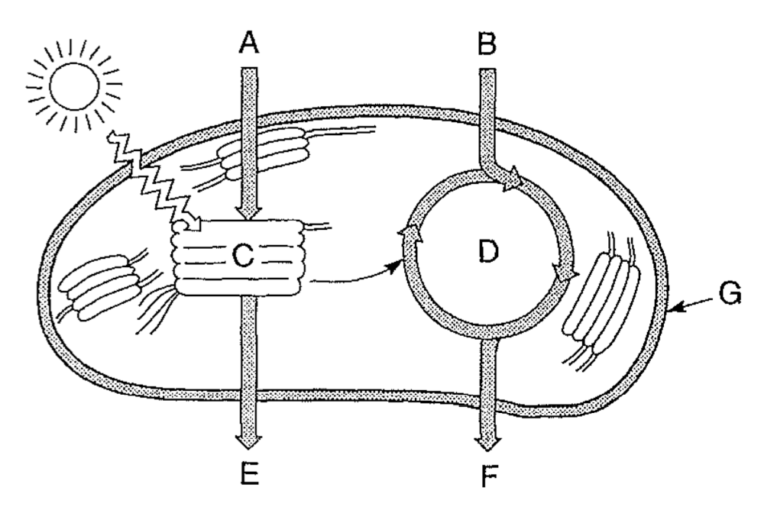

Enzymes are used to speed up chemical processes
Photosynthesis- transforms inorganic molecules into an organic molecule
Raw Materials: Water from ground CO2 from the air
Products: Glucose (C6H12O6) and O2 is released
Occurs: In the chloroplast-2 part reaction
Light dependent- (photolysis) H2O is split by sunlight releasing Hydrogen, Oxygen and ATP
Light independent- (Calvin cycle) Hydrogen is combined with CO2 from the air to make glucose
The ATP produced in the light reaction fuels the light independent reaction
Photosynthesis can be regulated by the Guard cells, they control gas exchange in the leafs

Respiration- transforms unusable energy into usable energy (glucose to ATP)
Raw Materials: Glucose from food and O2 from air
Products: ATP, CO2 and water
Occurs: cytoplasm and mitochondrion - 3 part reaction
Glycolysis-(cytoplasm) the splitting of glucose into ATP and pyruvate
Kreb’s cycle- Acetyl CoA is transformed into ATP, CO2 and NADH
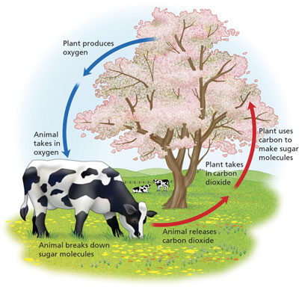
Electron transport chain- NADH is combined with O2 to produce ATP and H2O
ATP is used for the life functions- therefore all living things must preform respiration

Aerobic respiration- uses oxygen (cellular respiration) – 36 ATP
Anaerobic respiration- without oxygen (fermentation)– 2 ATP

Animals- respiration
Plants- photosynthesis and respiration

ADP + P = ATP (dead battery to charged battery)

H, C, O are all recycled through their respective cycles.

Yeast preform alcoholic fermentation- this produces alcohol and CO2
Yeast can be used to make bread rise because CO2 production forms bubbles in the dough
Yeast can be used to make alcohols like beer because it creates ethanol and CO2 for carbonation
The 2 processes above only occur without the presence of oxygen.

Contrary to yeast, our muscle cells produce lactic acid when they are oxygen deprived.

