Name ____________________________________________________ Due Date ____________
“Maintaining Homeostasis” Review Packet
Immunity and Lymphatic System
A. Disease
- Define disease and give an example
__________________________________________________________________________________________________________________________________________________________________________________________________________________________________
- Define pathogen and give an example
__________________________________________________________________________________________________________________________________________________________________________________________________________________________________
- Define symptoms and give an example
__________________________________________________________________________________________________________________________________________________________________________________________________________________________________
- How do the words symptoms, disease and pathogens differ?
___________________________________________________________________________________________________________________________________________________________________________________________________________________________________________________________________________________________________________________________________________________
- Examples of pathogens are ________________________________, _______________________________ and _______________________________
- How does the body discriminate a pathogen from its own body cells?
__________________________________________________________________________________________________________________________________________________________________________________________________________________________________
- what is a vector and why is it important to know the vector of diseases?
___________________________________________________________________________________________________________________________________________________________________________________________________________________________________________________________________________________________________________________________________________________

B. Innate Immunity
- Innate immunity is also called __________________________ immunity, this means that everyone is born with it and have the same innate defenses.
- Our first line of defense is our ___________________ which keeps pathogens out of the body, it has a layer of dead cells and oils that trap and kill pathogens.
- __________________________, __________________________________, and ________________________________ are found at our mucus membranes and contain _________________________________, an enzyme responsible for the destruction of bacterial cell walls.
- One last outer defense we have is massive amounts of ______________________ bacteria living all over our body, these organisms _________________________________ with harmful pathogens for living space and nutrients.
- Our body’s second line of defense includes the inflammatory response which is characterized by
_________________________________________ _________________________________________
_________________________________________ _________________________________________
- In the inflammatory response ______________________________ is released by damaged body cells and ______________________cells.
- How are blood vessels affected by histamine? Why is this helpful in terms of immunity?
________________________________________________________________________________________________________________________________________________________________________________________________________________________________________________________________________________________________________________________________________________
- Specific white blood cells are involved in the phagocytosis of pathogens, two examples of them are __________________________ and _____________________________
- Describe the process of phagocytosis of a pathogen
________________________________________________________________________________________________________________________________________________________________________________________________________________________________________________________________________________________________________________________________________________
C. Acquired Immunity
- How is acquired immunity different from innate immunity?
__________________________________________________________________________________________________________________________________________________________________________________________________________________________________
- Describe the humoral response (antibody immunity)
_____________________________________________________________________________________________________________________________________________________________________________________________________________________________________________________________________________________________________________________________________________________________________________________________________________________________________________________________________________________________________________________________________________________________________________________
- Describe how the cellular response (cell mediated immunity) differs from humoral.
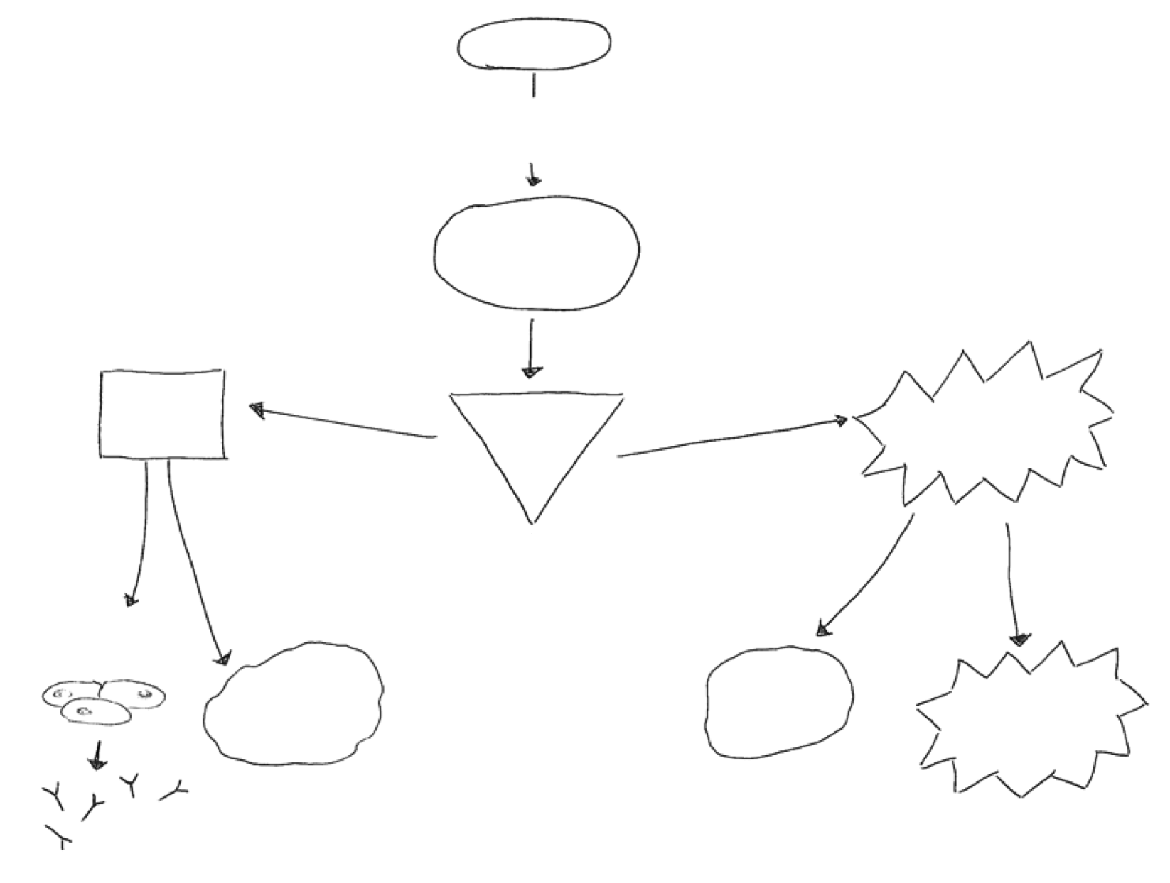
___________________________________________________________________________________________________________________________________________________________________________________________________________________________________________________________________________________________________________________________________________________

- Explain why a person is not likely to get the same disease twice
__________________________________________________________________________________________________________________________________________________________________________________________________________________________________
D. Immunity
- Explain the difference between active immunity and passive immunity
__________________________________________________________________________________________________________________________________________________________________________________________________________________________________

- What is a vaccination? Is this passive or active immunity? Why?
__________________________________________________________________________________________________________________________________________________________________________________________________________________________________
- Give two examples of passive immunity
__________________________________________________________________________________________________________________________________________________________________________________________________________________________________

E. Allergies and organ transplants
- Sometimes the body’s immune system will react to harmless substances in the environment. These reactions are called _____________________________
- The harmless substance such as mold, mildew, pollen, peanut butter or animal dander are called ________________________________

- The immune system responds to an allergen by releasing ______________________________, medicines that contain _______________________ can alleviate such symptoms

- A person’s immune system may attack a transplanted organ because it contains foreign _________________________. This is called organ ________________________. Patients are placed on _______________________________________ medication to prevent this.
- Why may a doctor use your own skin or tissue for a graft instead of a donor’s?
___________________________________________________________________________________________________________________________________________________________________________________________________________________________________________________________________________________________________________________________________________________
F. Blood and blood typing

Component | Description | Function
Red blood cell
White blood cell
Platelet
Plasma

Blood Type | Antigen present | Antibody in plasma | Can give to | Can receive from
 |  |  | A, AB, B, O
 |  |  |  | A, AB, B, O
 |  | Anti-A
 | A

- Which blood type is the universal donor and why?
__________________________________________________________________________________________________________________________________________________________________________________________________________________________________

- Which blood type is the universal recipient and why
__________________________________________________________________________________________________________________________________________________________________________________________________________________________________
Lymphatic System
- Cells are bathed in ________________________________, also known as ______________________________________ . This is important because ____________________________ works best across moist surfaces.
- This fluid is drained into special vessels called ____________________________________ vessels
- Once inside these vessels the fluid is called ___________________________ and it is eventually returned to the blood stream as ________________________, the liquid part of blood.
- What is the function of the lymph?
_________________________________________________________________________________________________________________ _________________________________________________________________________________________________________________ _________________________________________________________________________________________________________________
- The __________________________ filters the blood of pathogens and damaged blood cells.
- What is the role of the lymph nodes in the immune system?
__________________________________________________________________________________________________________________________________________________________________________________________________________________________________
- Sketch a diagram to illustrate the location of the ICF (Intercellular fluid)

Diseases of the immune system
- Describe H.I.V. and its effect on the body.
___________________________________________________________________________________________________________________________________________________________________________________________________________________________________________________________________________________________________________________________________________________

- How is H.I.V prevented? Treated?
__________________________________________________________________________________________________________________________________________________________________________________________________________________________________

- What is leukemia?
__________________________________________________________________________________________________________________________________________________________________________________________________________________________________

- How is leukemia treated?
___________________________________________________________________________________________________________________________________________________________________________________________________________________________________________________________________________________________________________________________________________________

- It is often said “people do not die from AIDS”. Explain why AIDS is considered a lethal disease.
____________________________________________________________________________________________________________________________________________________________________________________________________________________________________________________________________________________________________________________________________________________________________________________________________________________________________________________________________

