Name ________________________________________________ Class: ________ Due Date: _____________

Lab 19: Blood Disorders
_________________________________________________________________________________________________________________________

Purpose
To observe a “normal” blood sample and compare it to abnormal samples to determine the disorder present.
Introduction
Blood is a complex fluid tissue composed of liquid plasma and different cells and with different jobs. If a blood smear is observed under the microscope, three different cell types will be observed- red blood cells, white blood cells, and platelets. In a sample of normal blood, the numbers of blood cells are fairly constant. Sometimes, however, the number of cells will change due to a particular disease condition. Noticing this change in number can help a physician in the diagnosis of a blood disease.
White blood cells, also known as leukocytes (leuko=white, cyte=cell) are responsible for the body’s immune response. White blood cells unlike the other types of blood cells have a nucleus and come in 5 main classes. They are made in the bone marrow and can mature in other organs. WBC’s can live for years but healthy individuals tend to have low WBC numbers. Approx. 1:1000 when compared to RBC’s.
Red blood cells, also known as erythrocytes (erythro=red, cyte=cell) are responsible for the transport of Oxygen and removal of CO₂. They lack a nucleus and last an average of 120 days. Once they have run their course they are broken down in the spleen and liver. New red blood cells are produced in the bone marrow.
Platelets, also known as thrombocytes (thrombus=clot, cyte=cell) are responsible for clotting of blood. These cell fragments are produced in the bone marrow and are activated when blood vessels are damaged.
Materials

- Blood Sample Pictures
- Case Histories

Pre-Lab Questions
- What 3 cell types are present in blood and what is the function of each?
___________________________________________________________________________________________________________________________
______________________________________________________________________________________________________________________________________________________________________________________________________________________________________________________
- How do doctors use a blood sample to determine blood disorders?
______________________________________________________________________________________________________________________________________________________________________________________________________________________________________________________

Procedure
Part A- Normal Blood Sample
- Examine Figure 1, which shows a normal blood sample magnified 1,000 times.
- Count each cell type present and record their density in the analysis table in the observations section. Use the following information to help
  - Red Blood Cells (RBC) - round, very numerous, no nucleus.
  - White blood cells (WBC) - round, few in number, larger than red blood cells, nucleus present.
  - Platelets – dot-like cell fragments, fewer in number than red, but greater in number than white, extremely small.
- After the cells are counted rank them in order from most abundant (1) to least (3), this information will be helpful when determining which disease the individual has.
Part B- Abnormal Blood Samples
- Examine figures 2 to 6. These figures represent human blood samples from people with certain diseases.
- Count each cell type and record the number for each cell type in the sample in the analysis table in the proper column.
- Complete the rank columns using the numbers 1 to 3, as done with the normal blood smear.
Part C- Diagnosing Blood Disorders
- Read over the following case histories for five hospital patients.
- Match each case history with the appropriate blood sample (Figures 2-6)
- Record the name of each disease (Disease diagnosis) in the correct column of the analysis table.
Cell Type | Figure 1 |  | Figure 2 |  | Figure 3 |  | Figure 4 |  | Figure 5 |  | Figure 6
 | # of | Rank | # of | Rank | # of | Rank | # of | Rank | # of | Rank | # of | Rank
Red
White
Platelet
Disease Diagnosis | Normal Blood

Case History: Female, Black, age 18; poor nutrition, complains of
always being tired and having no energy.
Blood analysis: Red blood cells: low in number, a few with unusual
shape.
Blood rank- red =1, platelets =2, white =3
Disease diagnosis: Iron-deficiency anemia (an= no, emia= blood)

Case History: Male, Black, age 15; is always tired and short of breath.
Blood analysis: Red blood cells low in number and many crescent shaped.
Disease Diagnosis: Sickle cell anemia

Case History: Female, Asian, age 23; has fever, sore throat and frequent
nose bleeds.
Blood analysis: Red blood cells low in number, white blood cells abnormally
high in number.
Disease Diagnosis: Leukemia (form of cancer) (leuk= white, emia= blood)

Case History: Male, Caucasian age 68; has frequent headaches, nosebleeds,
High blood pressure and very red complexion.
Blood analysis: Red blood cells- a high number
Disease diagnosis: Polycythemia (poly= many, cyth= cell, emia= blood)

Case History: Female, Indian age 28; has sudden appearance of purple marks,
bruises easily, blood does not clot easily after a cut
Blood analysis: platelets very few in number
Disease diagnosis: Thrombocytopenia (thrombo= platelet, cyto= cell, penia= shortage)

Analyze and Conclude
- Blood cells do not last forever. The regularly wear out and need to be replaced. Where are the new blood cells produced? Where are old blood cells removed from the blood?
______________________________________________________________________________________________________________________________________________________________________________________________________________________________________________________
- In a normal healthy person’s drop of blood, which cells are the most numerous? Least numerous?
______________________________________________________________________________________________________________________________________________________________________________________________________________________________________________________
- Why does a person with anemia often feel tired and easily become short of breath?
______________________________________________________________________________________________________________________________________________________________________________________________________________________________________________________
- The rank and number of blood cells in a normal person and one with sickle-cell anemia is almost identical. How can a doctor conclude that a person has sickle cell anemia?
______________________________________________________________________________________________________________________________________________________________________________________________________________________________________________________
- Why might a person with Thrombocytopenia have many bruises or purple marks?
______________________________________________________________________________________________________________________________________________________________________________________________________________________________________________________

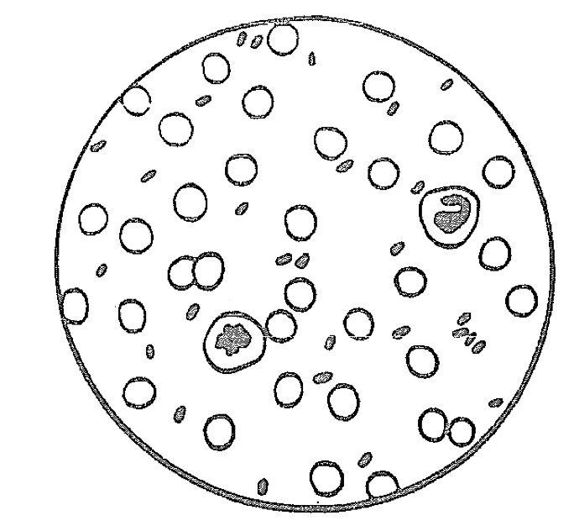
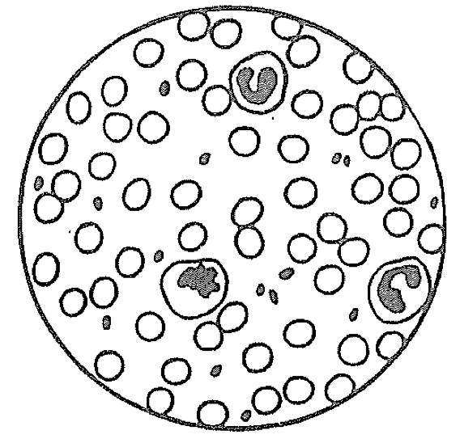
Figure 1 Figure 2

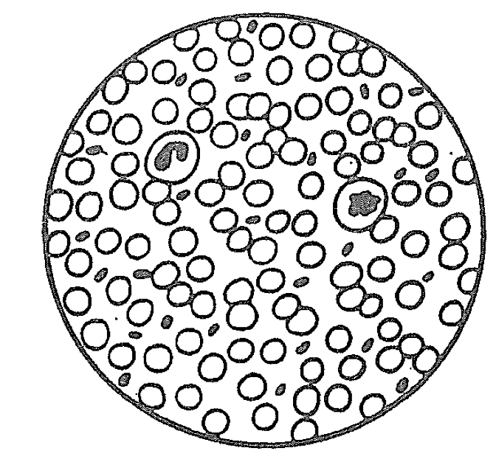
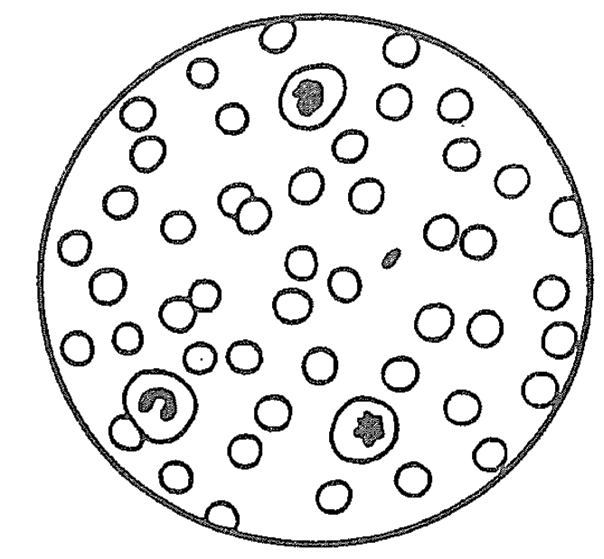
Figure 3 Figure 4

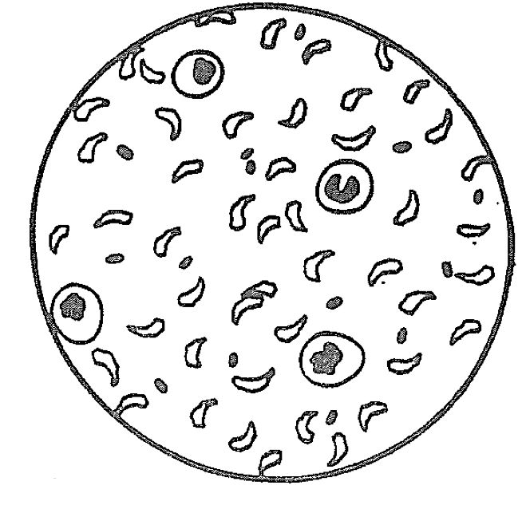
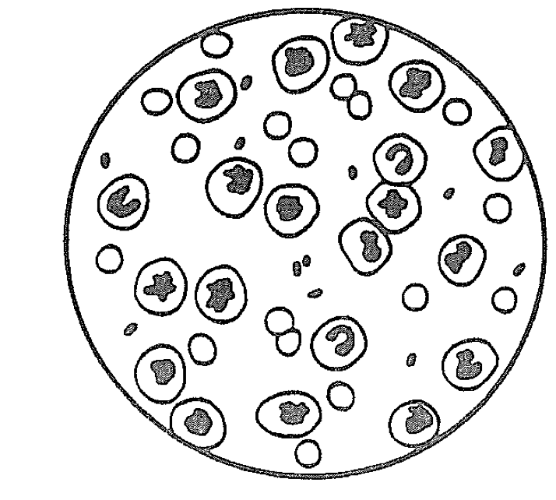
Figure 5 Figure 6

