Name ________________________________________________ Class: ________ Due Date: _____________

Lab 22: Blood Typing
_________________________________________________________________________________________________________________________

Purpose
To perform the standard tests used for blood type identification and apply the data found to a real life situation.
Introduction
The study of the blood is termed hematology. Blood has three main functions: transportation, regulation, and protection. Blood supplies cells with oxygen and nutrients while removing carbon dioxide and other waste products. Specialized cells within blood protect us by fighting sources of infection and coagulation prevents uncontrolled blood loss when we get injured. Prior to the 20th century many people with injuries and severe blood loss were likely to die. The practice of blood transfusions, the transfer of blood from one person to another, allowed many of these individuals to survive while some still died. It was not until 1901 when Karl Landsteiner discovered that there are at least four different kinds of human blood that blood transfusions became more successful.
Erythrocytes (red blood cell or RBC) carry proteins on their surface. This exercise we will focus on proteins A, B, and D (Rhesus). These proteins can function as antigens. Researchers have identified more than 100 erythrocyte antigens. An individual who is exposed to a foreign antigen (such as during an incompatible blood transfusion) may produce specialized proteins whose purpose is the destruction of the foreign antigen. These proteins, which are located in the plasma portion of the blood, are called antibodies. Once produced, an antibody can remain in the circulation for many years, ready to bind foreign antigens if introduced into the blood. Antibodies are specific; they will only bind to an antigen that is identical to the one that stimulated their production.
In this lab we will be doing blood analysis for a locate murder case. In order to determine the ABO blood type, we will use antibodies present within anti-A and anti-B sera.
If the blood type is A, the blood will agglutinate (clump) with the anti-A serum. It the blood is type B, it will agglutinate with anti-B serum. If the blood is type AB, it will agglutinate with both anti-A and anti-B sera. If your blood is type O (absence of proteins A and B), neither anti-A nor anti-B sera will cause agglutination.
Human erythrocytes are also classified according to the Rh factor as either Rh positive (Rh +) or Rh negative (Rh-), depending on whether the Rh antigen is present or absent. This antigen is called the D-antigen. In order to determine the presence or absence of the Rh protein we will use anti-D sera.

Materials

- 4 blood typing slides
- 4 synthetic blood samples
- Sample of blood from the weapon
- 3 Synthetic Anti serums
- Tooth picks
- Paper towels

Pre-Lab Questions
- Fill in the data table below using the information provided in the introduction and your notes:

Blood type  (% of population) | Antigens found on RBC | Antibodies found in blood plasma | Can give blood to: | Can Receive blood from:
A (39%)
B (12%)
AB (4%)
O (45%)
Blood Type | A-Antibody Serum | B-Antibody Serum
Type A
Type B
Type AB
Type O
Rh Serum = Clumping = Rh+ Blood

- Complete the following chart: Clumping (+) No Clumping (-)

Procedure
Part A- Determination of Suspect Blood Types
- Using the dropper vial, place a drop of the first synthetic blood sample in each well of the blood typing slide. Replace the cap on the dropper vial. Always replace the cap on one vial before opening the next vial to prevent cross contamination.
- Add a drop of synthetic anti-A (blue) to the well labeled A. Replace the cap.
- Add a drop of synthetic anti-B serum (yellow) to the well labeled B. Replace the cap.
- Add a drop of synthetic anti-Rh serum (clear) to the well labeled Rh. Replace the cap.
- Using a different color mixing stick for each well (blue for anti-A, yellow for anti-B, white for anti- Rh), gently stir the synthetic blood and anti-serum drops for 30 seconds. Remember to discard each mixing stick after a single use to avoid contamination of your samples.
- Carefully examine the thin films of liquid mixture left behind. If a film remains uniform in appearance, there is no agglutination. If the sample appears granular, agglutination has occurred. Determine the blood type of the sample using the data table below. Answer yes or no as to whether agglutination occurred in each sample. A positive agglutination reaction indicates the blood type.
- Record the results for the first blood sample in the data table.
- Thoroughly rinse the blood typing slide, then repeat steps 1 through 7 for synthetic blood samples 2,
3, and 4.

Part B- Determination of the “killer”
- Receive a sample of blood from your teacher that was found on the handle of a murder weapon
- Repeat steps 1 through 7 for this sample and record the results on the data table

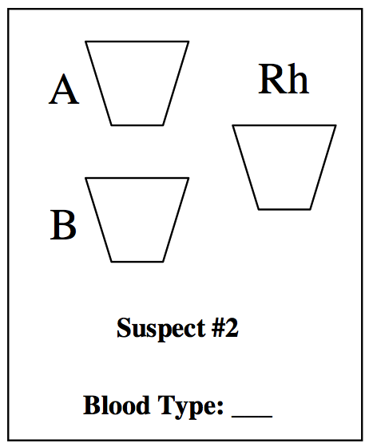
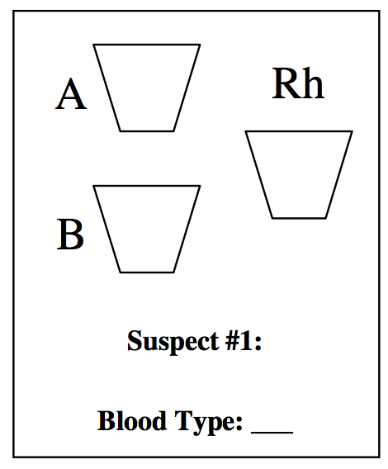
Data

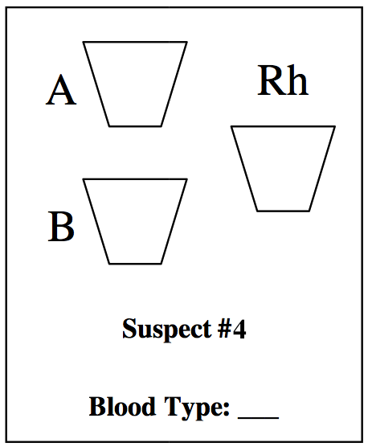
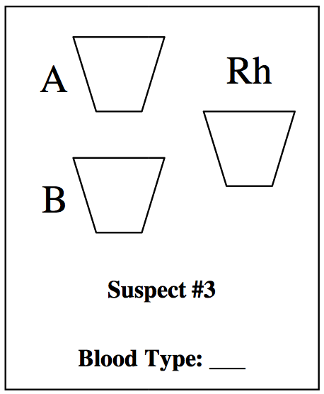

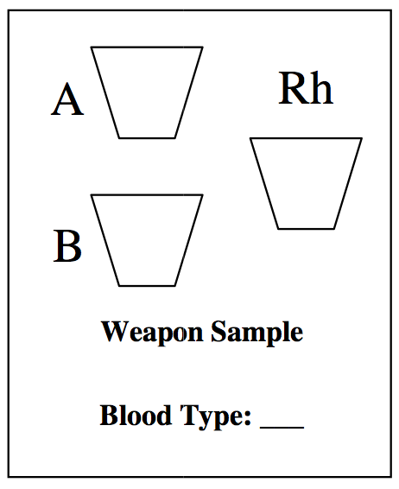

Analyze and Conclude
- Based on the data collected could you confidently testify in a court case to which suspect is the killer? Why or why not.
_________________________________________________________________________________________________________________________________________________________________________________________________________________________________________________________________________________________________________________________________________________________________________________
- Which, if any, of the blood samples tested can the patient with Type B+ blood receive? Explain why.
______________________________________________________________________________________________________________________________________________________________________________________________________________________________________________________
- Where are antigens located? _______________________________________________________________________________
- Where are antibodies located? _______________________________________________________________________________

- What might happen if someone with Type A received a transfusion of Type B blood?
______________________________________________________________________________________________________________________________________________________________________________________________________________________________________________________
- Why is Type O negative blood known as the universal donor?
______________________________________________________________________________________________________________________________________________________________________________________________________________________________________________________
- Why is Type AB positive blood known as the universal recipient?
______________________________________________________________________________________________________________________________________________________________________________________________________________________________________________________

