Name_________________________________________ Protein Synthesis

A. Protein Synthesis
- Protein synthesis occurs at organelles known as _________________________ which are made of _____________
- The instructions that code for the protein is known as ______________ and is located in the _________________________

- Because __________________ cannot leave the ______________________ protein synthesis must be broken up into 2 steps _______________________________ and ________________________________

- The first step is ____________________________________ and occurs in the _______________________. During this process a DNA template is used to create a strand of ________________. This strand carries the information to synthesize ONE protein and is known as a ____________________.

- A group of 3 nucleotides (triplet) on DNA is called a ______________ and on the mRNA it is called a ___________________

- The second step of protein synthesis is called ________________________________. This process takes place at the ________________________. The mRNA codons travel from the nucleus, through the ____________________________ to the ribosome where each codon is matched with is complimentary ________________________. Each anticodon is at the base of a ______________ molecule that is carries a specific _____________________________________. As the tRNA molecules attach to the mRNA in the ribosome they leave behind the _______________________________ they were carrying. These amino acids are bonded together by strong _____________________ bonds. As more and more amino acids are bonded together a _______________________________ is formed.

B. Proteins

- A proteins ___________________________ determines its function
- Its shape is based on its ________________________________________ sequence
- Its amino acid sequence is based on its __________________________________ sequence (codons)
List 4 compounds in the body that are made of proteins

C. Gene mutations
- Any change in an organism’s DNA codes is known as a _______________________________
- Gene mutations occur when only one gene on the chromosome is affected. This means that the production of only one __________________ is potentially altered.

There are four basic types of gene mutations: (complete the example of each below)
- A ______________________ mutation occurs when one nitrogenous base is replaced by a different one.

Original DNA template AAT TGC CCC AGG
Mutated DNA template

- An __________________________ mutation occurs when two adjacent nucleotides switch position

Original DNA template AAT TGC CCC AGG
Mutated DNA template

- An __________________________ occurs when an extra nucleotide is added to the original DNA code.

Original DNA template AAT TGC CCC AGG
Mutated DNA template

- A _________________________ mutation occurs when a nucleotide is dropped from the original DNA code

Original DNA template AAT TGC CCC AGG
Mutated DNA template

- Describe what a frame shift mutation is

- Which two types of gene mutations cause frame shifts?
___________________________ and ___________________________
- A mutation is a change in the DNA sequence. This sequence is then ______________________________ into mRNA codons, these codons are then ____________________________________ into amino acids. So a change in a DNA (triplet) _________ changes the mRNA __________ which can then code for a different ________________ _______________. A different amino acid sequence will create a different ________________________________
- Describe how a mutation can end up not affecting the protein produced.
__________________________________________________________________________________________________________________________________________________________________________________________________________________________________

D. Transcription and Translation Practice

DNA Template TAC GCG GTA CAT CCA TAG GAT GAA TTA ACT
mRNA codons ______ ______ ______ _______ _______ _______ _______ _______ _______ _______

tRNA anticodons _______ ______ ______ _______ _______ _______ _______ _______ _______ _______
Amino acids _______ ______ ______ _______ _______ _______ _______ _______ _______ _______

E. Gene Expression
- Every cell in your body contains ALL of your genetic information, this means every cell has the genes for every protein that your cells make. To be efficient cells only express or use certain genes to make the proteins that they need to carry out their function.

- Identify the tRNA, mRNA, codons, anticodons, ribosome and polypeptide.
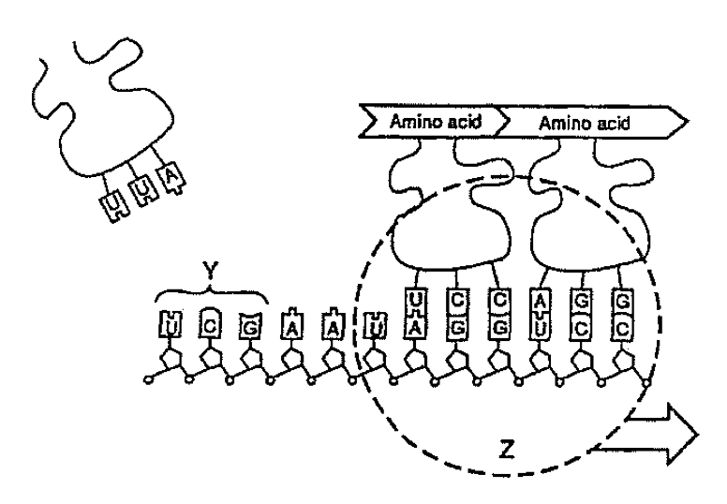

- Pay attention to what way the mRNA is traveling through the ribosome, what are the 4 amino acids, in order, that are coded for? (hint: the first codon is UCC)

_______________________ _______________________ _______________________ _______________________

- List 3 ways in which DNA and RNA differ
___________________________________________________________________________________________________________________________________________________________________________________________________________________________________________________________________________________________________________________________________________________________________________
- What are the three types of RNA and what is the role of each?
___________________________________________________________________________________________________________________________________________________________________________________________________________________________________________________________________________________________________________________________________________________________________________
- Where are all three types of RNA manufactured? ___________________________________________

Use the next two pages to draw out each of the processes involved in protein synthesis
Transcription

Translation

