Name: ____________________________________ **Unit 1 Review**  
Date ______________

**Characteristics of life**

1. ___________________ is the study of life
2. Another word for a living thing is an ___________________
3. Organisms are able to maintain a stable internal environment even though the external environment is constantly changing, this is called ________________________
4. Describe an example of homeostasis _________________________________________________________________________________________________________________________________________________________________________________________________________________________________________________________________________________
5. Define metabolism ___________________________________________________________________________________________

**Life Functions**

*Briefly describe the following*

1. Nutrition ____________________________________________________________________________
2. Transport ____________________________________________________________________________
3. Respiration ____________________________________________________________________________
4. Excretion ____________________________________________________________________________
5. Synthesis ____________________________________________________________________________
6. Growth ____________________________________________________________________________
7. Regulation ____________________________________________________________________________
8. Reproduction ____________________________________________________________________________

*Fill in the following:*

1. Oxygen moving into cells and carbon dioxide leaving the cells is an example of __________________
2. Cells carrying out ____________________ when they convert the stored energy in glucose to make ATP
3. Humans release carbon dioxide (metabolic waste) from the lungs. This is an example of ___________________
4. The human brain maintains a constant pH, this is an example of the life function of _____________________
5. Pick two life functions and explain how they work together to maintain homeostasis _______________________________________________________________________________________________________________________________________________________________________________________________________________________________________________________________________________________________________________________________________________________________________________________________________________________________________________________________
6. Reproduction is not necessary to sustain life of the individual organism, explain why it is then considered to be a life function. _________________________________________________________________________________________________________________________________________________________________________________________________________________________________________________________________________________

**Tools of the biologist**

1. What is the total magnification of a compound light microscope that has a 10x eye piece and a 43x objective   
    ____________
2. How did you arrive at that answer? ________________________________________________________________________________________________________________________________________________________________________________
3. How many micrometers are equal to 1 millimeter _____________
4. Which has a larger field of view, low or high power? ______________
5. When viewing a specimen a student should always start with _____ power and focus using the __________ adjustment
6. You should only have to adjust the _________________ adjustment when under high power.
7. As you increase magnification you must ________________ the amount of light
8. What could happen if you used the coarse adjustment on high power? ________________________________________________________________________________________________________________________________________________________________________________
9. In the circle below draw the letter “d” as it would appear if views through a microscope
10. The _____________________ is the most powerful microscope
11. What is the proper procedure for focusing an object under High power starting with placing the slide on the stage. ________________________________________________________________________________________________________________________________________________________________________________________________________________________________________________________________________________________________________________________________________________________________________________________________________________________________________________________________________________________________________________________________________________
12. What would you use a centrifuge for? ________________________________________________________________________________________
13. Gel electrophoresis separates _____and _____ fragments by size
14. What is chromatography used for? ________________________________________________________________________________________

*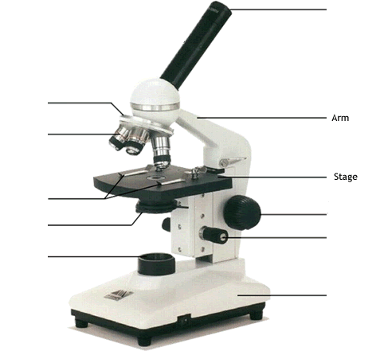Fill in the missing labels*

**The scientific method**

1. What is the scientific method? ___________________________________________________________________________________________
2. List the steps of the scientific method
   1. ________________________
   2. ________________________
   3. ________________________
   4. ________________________
   5. ________________________
3. Define a hypothesis ___________________________________________________________________________________________
4. In what form should your hypothesis be written ___________________________________________________
5. What is a control group and why is it necessary in an experiment ______________________________________________________________________________________________________________________________________________________________________________________
6. Why is it best to have a large sample size when conducting an experiment ___________________________________________________________________________________________
7. List three characteristics of a valid experiment _________________________________________________________________________________________________________________________________________________________________________________________________________________________________________________________________________________
8. When can results be reported as valid? ______________________________________________________________________________________________________________________________________________________________________________________
9. Does your hypothesis need to be proven in order to conduct a successful experiment? Why or why not ______________________________________________________________________________________________________________________________________________________________________________________

**Measuring**

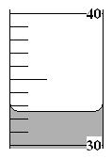

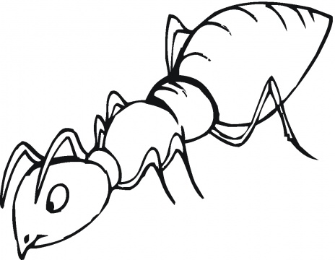



5000 µm

1. How long is the ant? _____________ mm
2. What is the reading in the graduated cylinder? ____________ ml
3. How big is the Black box ____________ µm
4. How many grams are in a kg ____________
5. When measuring a liquid you read at the bottom of the _______________

|  |  |
| --- | --- |
| **Temperature (°C)** | **Survival rate (%)** |
| 15 | 0 |
| 16 | 20 |
| 17 | 60 |
| 18 | 80 |
| 19 | 90 |
| 20 | 100 |
| 21 | 100 |
| 22 | 80 |
| 23 | 73 |
| 24 | 30 |
| 25 | 0 |

Based on her field experiments a scientist observed that a certain species of insects require a specific range of air temperatures in order to live. She tested her hypothesis by exposing larval stages of this species to varying air temperatures. The data from her experiments is shown below. Use the data to answer the following questions.

1. What is the independent variable in this experiment ___________________________________________________________________________________________
2. What is the dependent variable ___________________________________________________________________________________________
3. What type of graph would you use to display this experiment and why ______________________________________________________________________________________________________________________________________________________________________________________
4. Draw the type of graph described above. Be sure to label the axis.

|  |  |  |  |  |  |  |  |  |  |  |  |  |  |  |  |  |  |  |  |  |  |  |  |  |  |  |  |  |  |
| --- | --- | --- | --- | --- | --- | --- | --- | --- | --- | --- | --- | --- | --- | --- | --- | --- | --- | --- | --- | --- | --- | --- | --- | --- | --- | --- | --- | --- | --- |
|  |  |  |  |  |  |  |  |  |  |  |  |  |  |  |  |  |  |  |  |  |  |  |  |  |  |  |  |  |  |
|  |  |  |  |  |  |  |  |  |  |  |  |  |  |  |  |  |  |  |  |  |  |  |  |  |  |  |  |  |  |
|  |  |  |  |  |  |  |  |  |  |  |  |  |  |  |  |  |  |  |  |  |  |  |  |  |  |  |  |  |  |
|  |  |  |  |  |  |  |  |  |  |  |  |  |  |  |  |  |  |  |  |  |  |  |  |  |  |  |  |  |  |
|  |  |  |  |  |  |  |  |  |  |  |  |  |  |  |  |  |  |  |  |  |  |  |  |  |  |  |  |  |  |
|  |  |  |  |  |  |  |  |  |  |  |  |  |  |  |  |  |  |  |  |  |  |  |  |  |  |  |  |  |  |
|  |  |  |  |  |  |  |  |  |  |  |  |  |  |  |  |  |  |  |  |  |  |  |  |  |  |  |  |  |  |
|  |  |  |  |  |  |  |  |  |  |  |  |  |  |  |  |  |  |  |  |  |  |  |  |  |  |  |  |  |  |
|  |  |  |  |  |  |  |  |  |  |  |  |  |  |  |  |  |  |  |  |  |  |  |  |  |  |  |  |  |  |
|  |  |  |  |  |  |  |  |  |  |  |  |  |  |  |  |  |  |  |  |  |  |  |  |  |  |  |  |  |  |
|  |  |  |  |  |  |  |  |  |  |  |  |  |  |  |  |  |  |  |  |  |  |  |  |  |  |  |  |  |  |
|  |  |  |  |  |  |  |  |  |  |  |  |  |  |  |  |  |  |  |  |  |  |  |  |  |  |  |  |  |  |
|  |  |  |  |  |  |  |  |  |  |  |  |  |  |  |  |  |  |  |  |  |  |  |  |  |  |  |  |  |  |
|  |  |  |  |  |  |  |  |  |  |  |  |  |  |  |  |  |  |  |  |  |  |  |  |  |  |  |  |  |  |
|  |  |  |  |  |  |  |  |  |  |  |  |  |  |  |  |  |  |  |  |  |  |  |  |  |  |  |  |  |  |
|  |  |  |  |  |  |  |  |  |  |  |  |  |  |  |  |  |  |  |  |  |  |  |  |  |  |  |  |  |  |
|  |  |  |  |  |  |  |  |  |  |  |  |  |  |  |  |  |  |  |  |  |  |  |  |  |  |  |  |  |  |
|  |  |  |  |  |  |  |  |  |  |  |  |  |  |  |  |  |  |  |  |  |  |  |  |  |  |  |  |  |  |
|  |  |  |  |  |  |  |  |  |  |  |  |  |  |  |  |  |  |  |  |  |  |  |  |  |  |  |  |  |  |
|  |  |  |  |  |  |  |  |  |  |  |  |  |  |  |  |  |  |  |  |  |  |  |  |  |  |  |  |  |  |