Name ____________________________________________________ Due Date ____________
Energetics Review Packet
Photosynthesis and cellular respiration

A. Energetics
- Define nutrition: __________________________________________________________________________________________________________________________________________________________________________________________________________________________________
- Organisms that synthesize their own food are called ______________________________ or ______________________________
- Organisms that must consume other organisms to obtain nutrition are called ________________________ or ______________________________
- Why do cells have to convert glucose to ATP?
__________________________________________________________________________________________________________________________________________________________________________________________________________________________________
- What does ATP stand for? ______________________________________________________
- Describe the relationship between ADP and ATP
__________________________________________________________________________________________________________________________________________________________________________________________________________________________________
- What is the initial source of all energy on earth? ______________________________________
- Draw an ATP molecule below and draw an arrow to where the energy is stored

B. Photosynthesis

- Any organism that can synthesize organic compounds from inorganic compounds is called an __________________________________
- Define photosynthesis
__________________________________________________________________________________________________________________________________________________________________________________________________________________________________
- Photosynthesis takes place in organelles known as ___________________________________
- These organelles contain a green pigment called ___________________________________

- Photosynthesis can be divided into two basic steps.
  - The first step is called _____________________________________________________ or ________________________________________________________.
  - The second step is called _______________________________________________________ or ________________________________________________________
- Define photolysis:
_________________________________________________________________________________________________________________
- Write an equation that represents photolysis
_________________________________________________________________________________________________________________

- Which wavelengths of light are absorbed by chlorophyll? _______________________________________________
- Which wavelength of light is reflected by chlorophyll? ___________________________________________________
- Where in the chloroplast do the light reactions occur? ___________________________________________________

- List the three products of the light reactions :
________________________________ __________________________________ __________________________________
- Briefly explain where each of the three products from above ends up:
___________________________________________________________________________________________________________________________________________________________________________________________________________________________________________________________________________________________________________________________________________________

- Write an equation that represents carbon fixation:
_________________________________________________________________________________________________________________
- Where in the chloroplast does the Calvin cycle occur? ___________________________________________________
- What important organic compound is synthesized from PGAL
- List two reasons why autotrophic organisms are important to animals:
__________________________________________________________________________________________________________________________________________________________________________________________________________________________________
- Draw and label a diagram of a chloroplast in the space below:

- Write the overall equation for photosynthesis:
____________________________________________________________________________________________________________

C. Structure of the Leaf
E
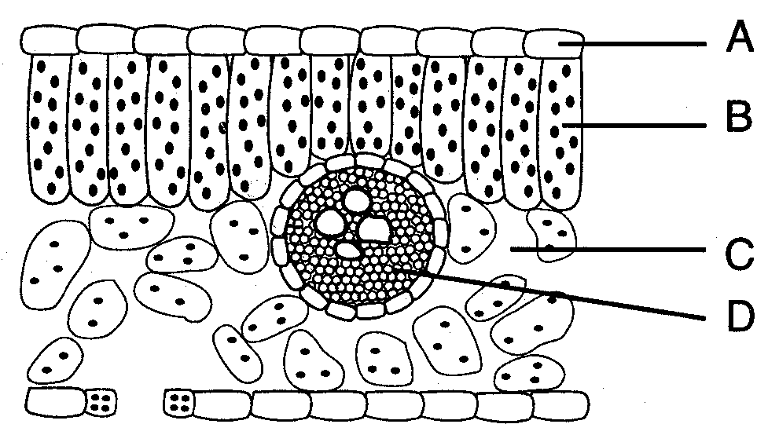

G
F

Identify the letter that represents the part of the leaf and describe its function:
_______ Cuticle: ________________________________________________________________________________________________________
_______ Epidermis: ____________________________________________________________________________________________________
_______ Palisades Layer: ______________________________________________________________________________________________
_______ Spongy Layer: ________________________________________________________________________________________________
_______ Guard cells: ___________________________________________________________________________________________________
_______ Stomate: _______________________________________________________________________________________________________
_______ Vein: ___________________________________________________________________________________________________________
Xylem _________________________________________________________________________________________________________
Phloem________________________________________________________________________________________________________

D. Cellular Respiration
- Define cellular respiration
__________________________________________________________________________________________________________________________________________________________________________________________________________________________________
- the two basic types of cellular respiration are ____________________________________ and ____________________________________.
- The energy rich molecule produced from respiration is __________________

E. Anaerobic respiration
- The splitting of glucose molecules is called _________________________________, which takes place in the ____________________________________ of the cell.
- Write the equation that shows this:
____________________________________________________________________________________________________________
- The process by which pyruvic acid is converted into alcohol and CO₂ is known as ________________________________________ and occurs in _____________________
- Write the overall equation that shows this : __________________________________________________________________________________________
- The process by which pyruvic acid is converted into lactic acid animal tissue is called _______________________________________ this only occurs in the absence of ___________________________.
- Write the overall equation that shows this:
_________________________________________________________________________________________________________________
- What compound is responsible for muscle fatigue _________________________________________
- The net gain of ATP from anaerobic respiration is ______________________

F. Aerobic respiration
- Aerobic respiration requires ____________________________
- Aerobic respiration can be broken down into three steps
  - _________________________________________________
  - _________________________________________________
  - _________________________________________________
- _________________________________________ occurs in the cytoplasm, while the ___________________________________ and ______________________________ occur with special enzymes in the mitochondrion.
- Write the equations for each stage of aerobic respiration
_________________________________________________________________________________________________________________
_________________________________________________________________________________________________________________
_________________________________________________________________________________________________________________
- The net gain of ATP from aerobic respiration of one glucose is _______________
- Explain the function of oxygen in the electron transport chain
_________________________________________________________________________________________________________________
- Explain why aerobic respiration is more efficient than anaerobic respiration
__________________________________________________________________________________________________________________________________________________________________________________________________________________________________
- Write the overall equation for aerobic respiration
_________________________________________________________________________________________________________________
- Name two metabolic wastes that result from aerobic respiration
____________________________________ ___________________________________

- Explain the relationship between breathing and cellular respiration
____________________________________________________________________________________________________________________________________________________________________________________________________________________________________________________________________________________________________________________________________________________________________________________________________________________________________________________________________

G. Tie together

- Explain how photosynthesis and cellular respiration work together and are cyclic. You can use words or a diagram, or both.

