Name: __________________________________________ Immunity Worksheet 1
Disease

- What is the definition of disease?
__________________________________________________________________________________________________________________________________________________________________________________________________________________________________

- How do infectious diseases differ from other types of disease?
__________________________________________________________________________________________________________________________________________________________________________________________________________________________________

- What is a pathogen?
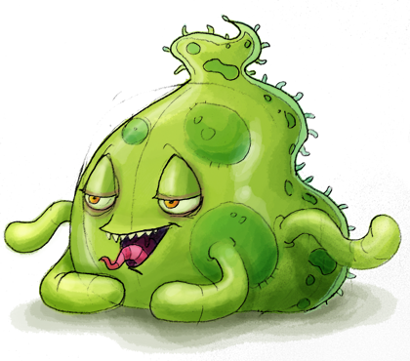
_________________________________________________________________________________________________________________
- What are the types of pathogens?
  - _________________________________________________
  - _________________________________________________
  - _________________________________________________
  - _________________________________________________
  - _________________________________________________

- What is a host?
_________________________________________________________________________________________________________________

- What is a vector of disease?
__________________________________________________________________________________________________________________________________________________________________________________________________________________________________

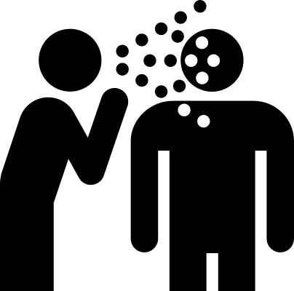
- What are the modes of disease transmission?
- _______________________________________________ to person
- _______________________________________________ to person
- _______________________________________________ to person
- _______________________________________________ to person

- What is the difference between disease and pathogen, give examples
___________________________________________________________________________________________________________________________________________________________________________________________________________________________________________________________________________________________________________________________________________________

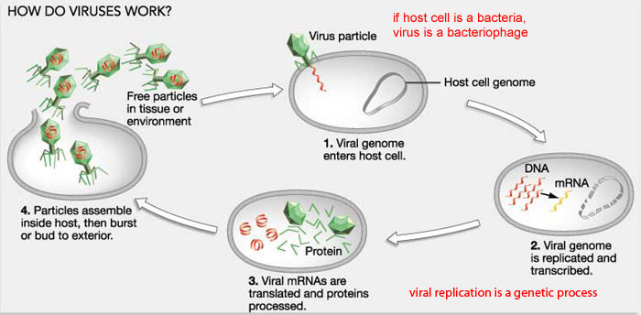
- What type of pathogen is not defined as “alive” ___________________________________________________________

