Name: __________________________________________ Immunity Worksheet 4
Blood typing
Either fill in the missing information or circle the correct term in italics
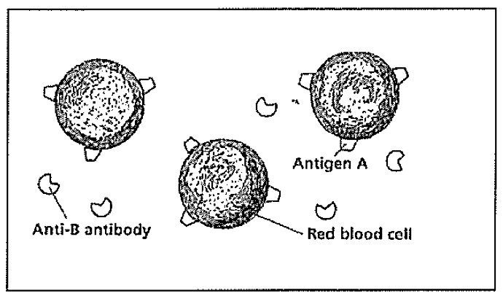

These red blood cells have _______________ antigens on them. Antibodies for ___________ antigens are present in the plasma. The antibodies produced will / will not bind with the proteins on the “self” cells. This blood type is __________

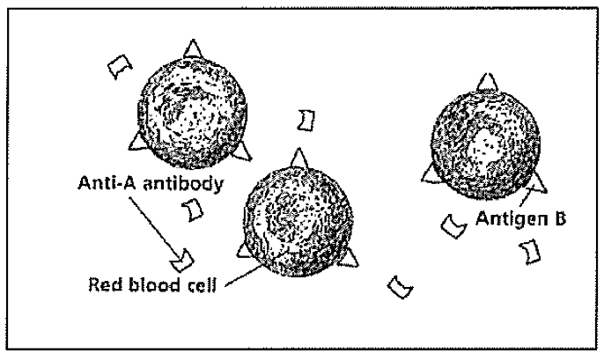

These red blood cells have _______________ antigens on them. Antibodies for ___________ antigens are present in the plasma. The antibodies produced will / will not bind with the proteins on the “self” cells. This blood type is __________

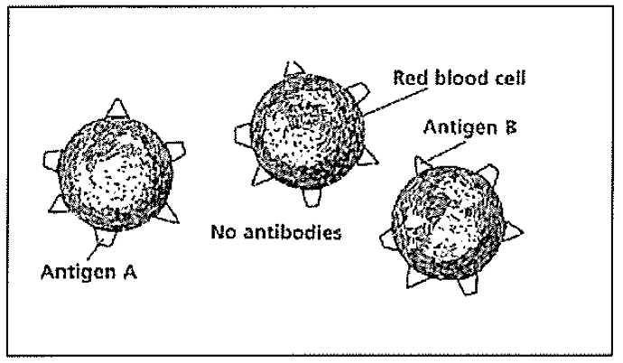

These red blood cells do / do not have proteins on them and antibodies are / are not produced. This blood type is __________

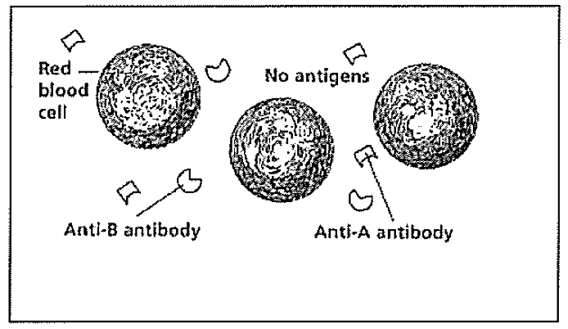

These red blood cells do / do not have proteins on them and antibodies are / are not produced. This blood type is __________

For each diagram, draw the image you would see if antibodies were added to the following blood slides. Use the key provided below. Anti-A serum contains A antibodies, Anti-B serum contains B antibodies

Normal blood Clotted blood

Type A Blood Type B Blood
Anti-A Anti-B
Anti-A Anti-B

Type O Blood Type AB Blood
Anti-A Anti-B
Anti-A Anti-B

