Name: __________________________________________ Immunity Worksheet 5
Lymphatic System
Either fill in the missing information or circle the correct term in italics

Lymphatic System
- The lymphatic system is an ___________________ circulatory system.
- The fluid part of blood known as _________________________ leaks out of the capillaries and bathes the body cells. This allows for _____________________________ to occur more effienently.
- When the blood plamsa surrounds body cells it is called __________________________________ fluid. This fluid picks up debris, wastes and pathogens floating between cells and enters the lymphatic vessels.
- When the fluid enters these vessels its name changes once again, it is now called __________________.
- As this fluid travels back to the heart is is filtered along the way at ___________________________________ which contain high concentrations of white blood cells called _________________________________________ (B and T cells)

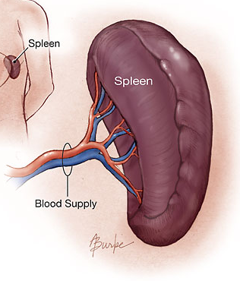
Lymph node
- Small mass of tissue that contains lymphocytes
- Filters pathogens from the lymph

The Spleen
- The spleen is in the upper _________________________.
- It filters pathogens and worn out red blood cells
from the ___________________, and then lymphocytes in
the spleen destroy them.
- It also acts as a blood reservoir
Thymus
- located in the upper chest behind the breast bone. It stores and matures ____________________________.
Tonsils
- They trap pathogens, which are destroyed by lymphocytes in the tonsils.

Types of lymphocytes
- ____________________ (thymus-dependent)
- ____________________ (bone marrow-derived)
- ____________________ (natural killer)

