Name _____________________________________________ Nervous system HW

Draw and label a Neuron:
dendrites, cyton, nucleus, myelin, axon, Schwann cells, terminal branches, node, synaptic knobs

Draw and label a Synapse:
synaptic knob, synapse, neurotransmitters, mitochondria, dendrite, receptors, synaptic vesicle

Human Nervous System

Involuntary

Voluntary

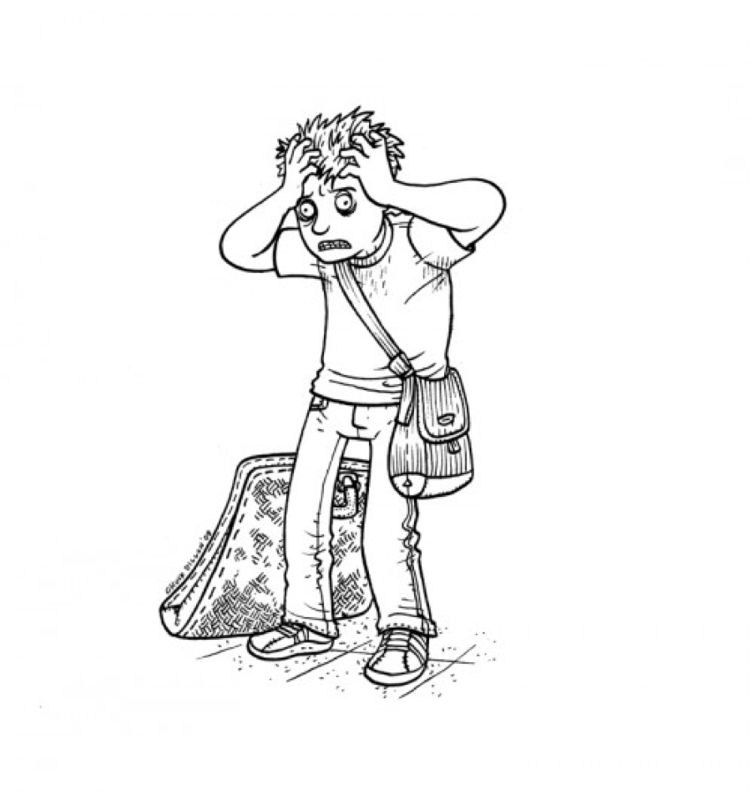

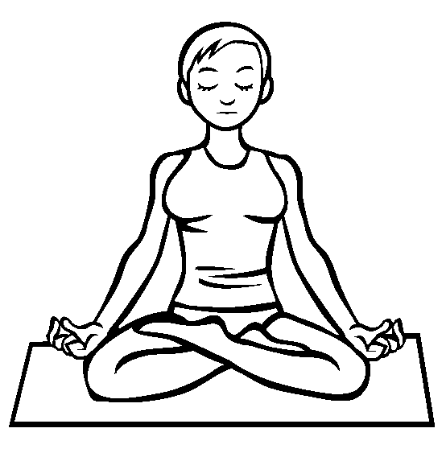

Draw and label an action potential as it travels down an axon:
action potential, resting, direction of impulse, +’s and –‘s

What are the three types of neurons? ______________________________________________________________________________

What is the name of the electrochemical message sent through neurons? _____________________________________
What are the three parts of the Brain and their function
- _____________________________________________________________________________________________________________
- _____________________________________________________________________________________________________________
- _____________________________________________________________________________________________________________
What type of response is processed by the spine and not the brain? ___________________________________
What is the purpose of the myelin sheath?
_________________________________________________________________________________________________________________________
What cell produces the myelin? _________________________________________________
What is the area between two adjacent neurons called? _________________________________________________
What chemical molecule do the synaptic knobs release? ____________________________________________

Label the reflex arc below:
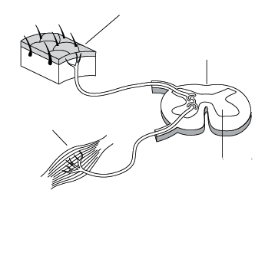
receptor, effector, spinal cord, vertebrae, sensory neuron, interneuron, motor neuron

