Name ____________________________________________________ Due Date ____________
“Gas Exchange and Transport” Review Packet
Circulatory and Respiratory Systems

A. Circulatory Systems

- All circulatory systems must have these three components:
- ____________________________________________
- ____________________________________________
- ____________________________________________
- Describe how an open circulatory system differs from a closed circulatory system.
__________________________________________________________________________________________________________________________________________________________________________________________________________________________________
- What are the 4 major functions of the circulatory system
- _________________________________________________________________________________________________________________
- _________________________________________________________________________________________________________________
- _________________________________________________________________________________________________________________
- _________________________________________________________________________________________________________________

- The human circulation system is considered a double loop system, one loop goes to the lungs and is called _________________________________ circulation. Here _________________ is dropped off and ___________________ is picked up. The other loop goes to the body cells and is called ________________________________ circulation. In this loop ________________________ is dropped off at cells and __________________ is picked up.
- There is a third loop called ______________________________ or _________________________________ circulation. This supplies ___________________________ to the cells of the heart and keeps it pumping.

B. Human Circulatory System

- Heart
- The human heart has ______________ chambers. Blood enters the heart into the ________________________ and is pushed out of the heart by the _____________________________.
- Between the chambers are _______________________ that prevent the black flow of blood. The ______________________ separates the right and left side of the heart and prevents ________________________ rich and _________________________ poor blood from mixing.
- Another term for oxygen rich blood is ________________________________________
- Another term for oxygen poor blood is ________________________________________

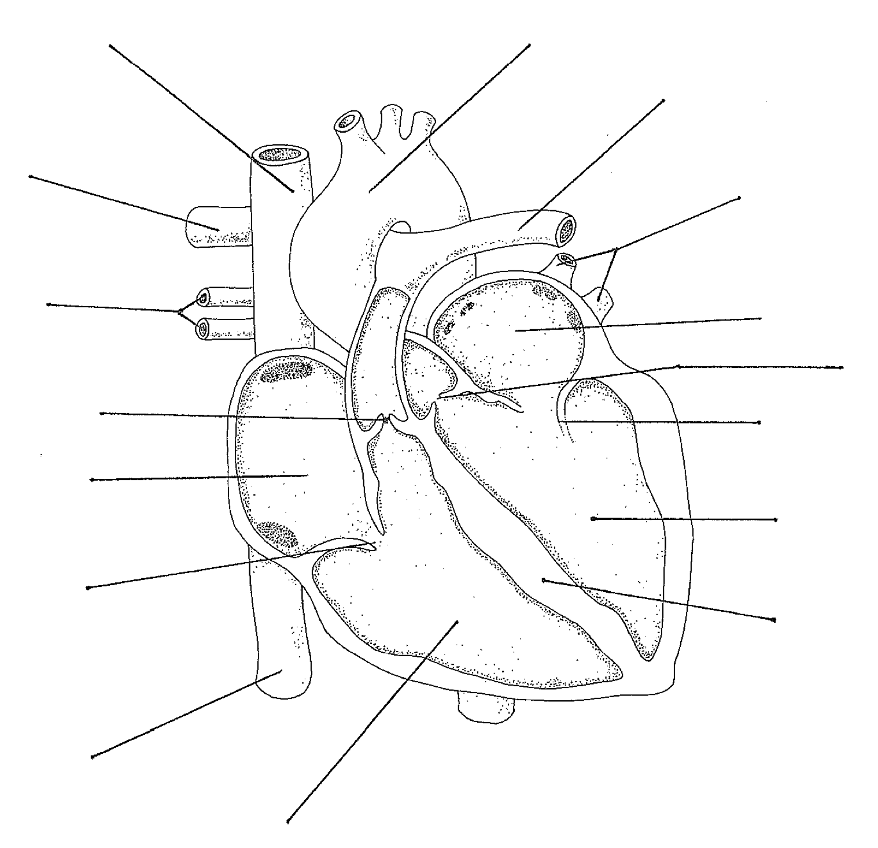

Include arrows that show the path of blood
- Vessels
- ______________________________ are responsible for carrying blood away from the heart. They are __________________________ and elastic and made of _______________________ muscle.
- ______________________________ are responsible for carrying blood back to the heart. They have ________________________ to prevent the backflow of blood. Contractions of skeletal ____________________________ help push blood back to the heart.
- _________________________________ are the smallest blood vessels, only ______________________________ thick. This is where ______________________________________________ occurs. Blood cells travel __________________ file through the capillaries. They are the link between the arteries and veins.
- The _______________________ is the largest artery in the body and takes oxygen ___________________ blood away from the heart
- The _____________________________________________ and____________________________________________ are the largest veins in the body and bring oxygen ____________________ blood into the heart.
- The _____________________________________ artery and ________________________________ vein are responsible for bringing blood to the lungs and returning it to the heart respectively.
- Describe why nutrients and gasses are exchanged between the blood and body cells in capillaries and not the other vessels
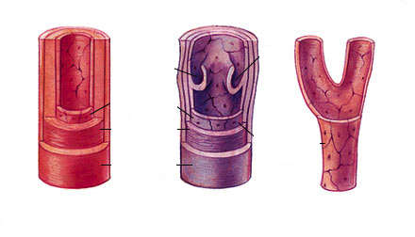
_________________________________________________________________________________________________________________________________________________________________________________________________________________________

- Blood
- __________________________________________ also known as erythrocytes, are responsible for transporting __________________________. They are produced in the ________________________________ and live approximately ______________ days. They have no ____________________ because they are filled with a protein, ___________________________________. Once they have run their course, they are destroyed in the ________________________ and _________________________
- __________________________________________ also known as leukocytes, are responsible for _______________________ ____________________________. Unlike red blood cells, leukocytes have a _______________________ and can live for many years. They are part of the Immune system and there are 5 different classes.
- _________________________________ also known as thrombocytes are responsible for _____________________________. They are produced in the ____________________________.
- _________________________________ is the liquid part of blood and is 90% water. The other 10% is dissolved gasses, proteins and nutrients. This is responsible for transporting ________________________ which is a waste product of respiration
- What are the 4 major blood types? _________________________________________
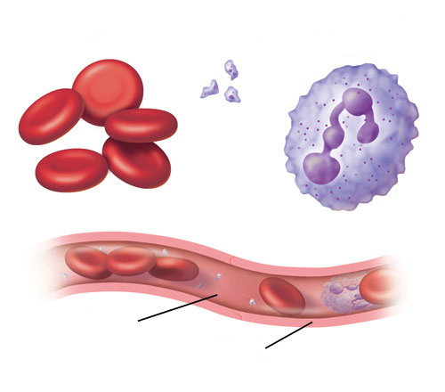
- Label the diagram below and indicate what function or role they play.

C. Lymphatic System
- The open circulatory system in humans is called the _________________________________ system. Not every cell in the body is in __________________________ contact with capillaries but all are very close. In order for nutrients to reach these cells they are bathed in a fluid called _______________________________________________ (ICF). This is important because diffusion occurs best across ______________________________ surfaces. The ICF is actually _________________________ that leaks out of the blood that isn’t reabsorbed by the capillaries. In order to filter the ICF and prevent edema the ICF is returned to the blood by the lymphatic system. Once this fluid enters the lymphatic vessel it is now called ________________________.
- What are the three names given to the fluid involved in the lymphatic system, and where are they called by this name
- ___________________________________________________________________________________________________________________________
- ___________________________________________________________________________________________________________________________
- ___________________________________________________________________________________________________________________________

Complete the following:

D. Respiratory system
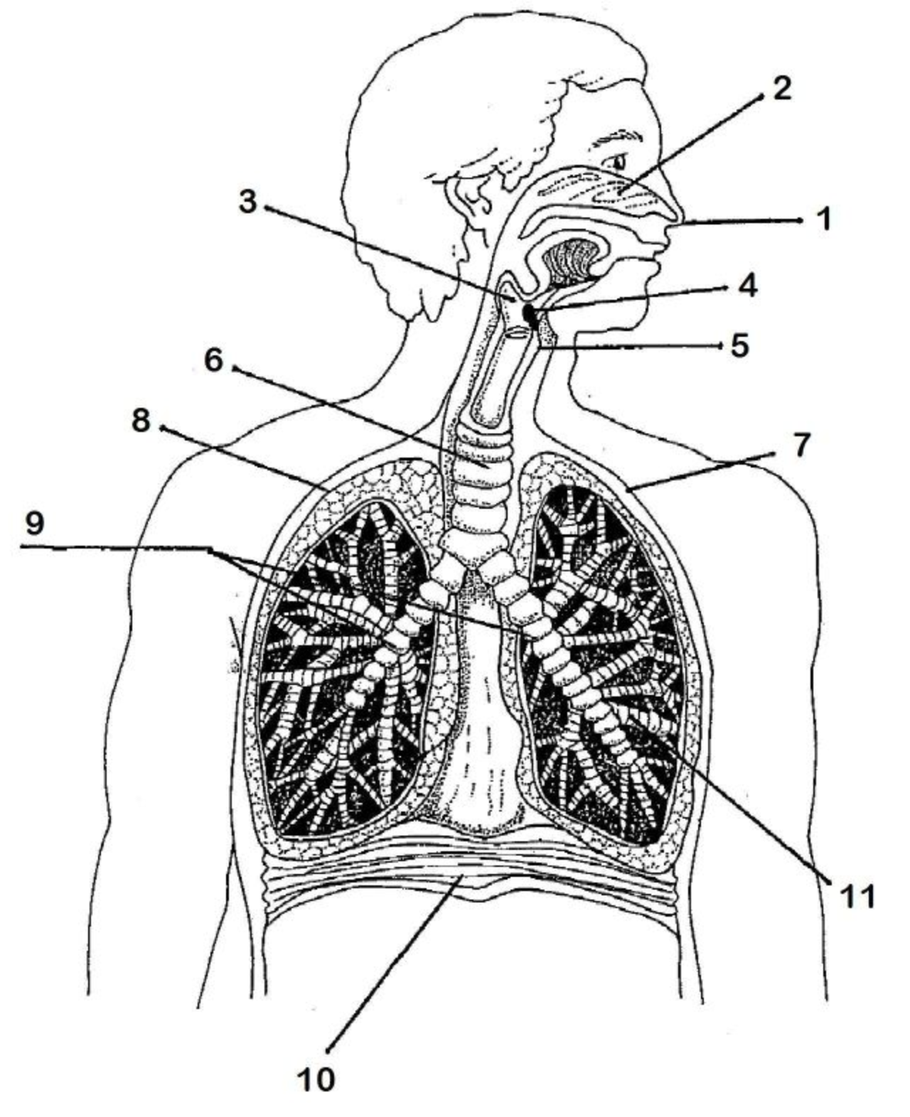
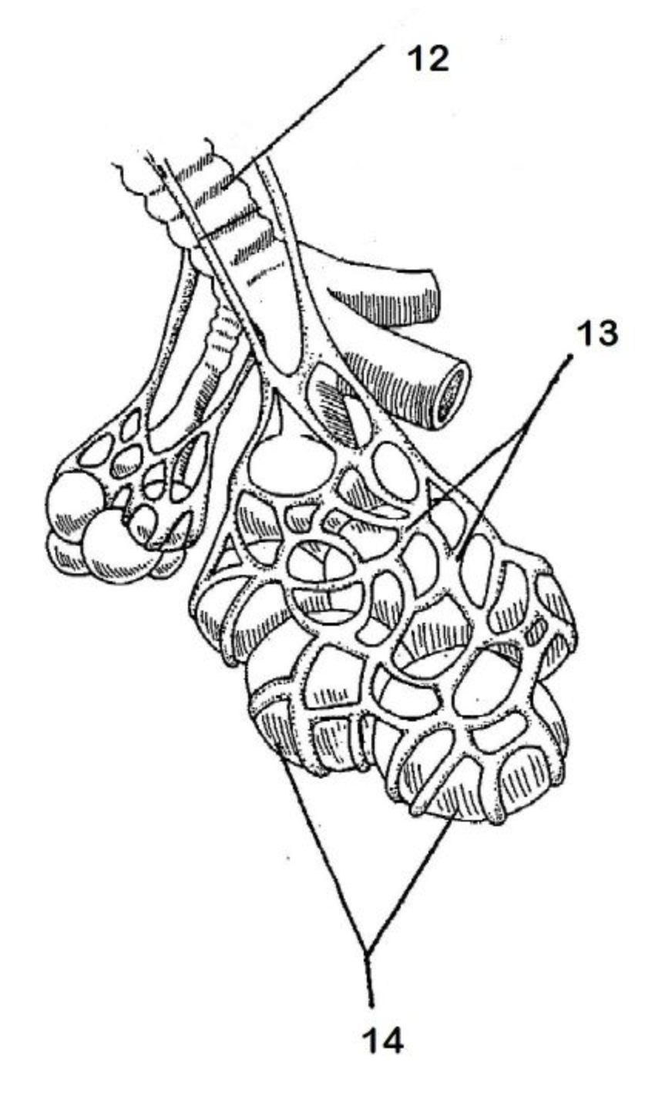
Label the following and describe each component below:

- ___________________________________________________________________________________________________________________________
- ________________________________________________________________________________________________________________________
- ________________________________________________________________________________________________________________________
- ________________________________________________________________________________________________________________________
- ________________________________________________________________________________________________________________________
- ________________________________________________________________________________________________________________________
- ________________________________________________________________________________________________________________________
- ________________________________________________________________________________________________________________________
- ________________________________________________________________________________________________________________________
- ________________________________________________________________________________________________________________________
- ________________________________________________________________________________________________________________________
- ________________________________________________________________________________________________________________________
- ________________________________________________________________________________________________________________________
- ________________________________________________________________________________________________________________________
- The main function of the respiratory system is to exchange _______________________ between the environment and the blood
- We take in _____________________________ and expel out __________________________, water and heat.
- What life function is associated with the respiratory system? ____________________________________________
- What life function is associated with the circulatory system? _____________________________________________

- How are the respiratory and circulatory systems connected?
_________________________________________________________________________________________________________________________________________________________________________________________________________________________________________________________________________________________________________________________________________________________________________________
E. Breathing
- The _______________________________ is responsible for breathing. As it contracts and the chest cavity expands and ________________________________ occurs. When it relaxes and the chest cavity contracts and ____________________________ occurs.
- The _______________________________ is the part of the brain that controls breathing rate. It detects changes in the ________ of the blood. As ________________________ accumulates in the blood, it is converted into _____________________ acid. The ____________________________________ must be removed from the blood, so the breathing rate increases.
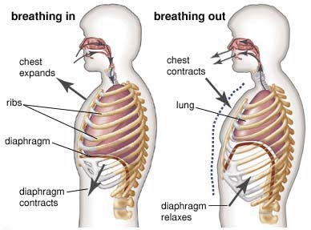

F. Gas Exchange
Gas exchange in the lungs (at the alveoli)

Gas exchange at the body cells

