Name: _______________________________________________ Nervous System Worksheet 1

- What is the name of the electrochemical message sent through neurons? _____________________________
- What is the name of the cell below? _____________________________
- Label the diagram below:
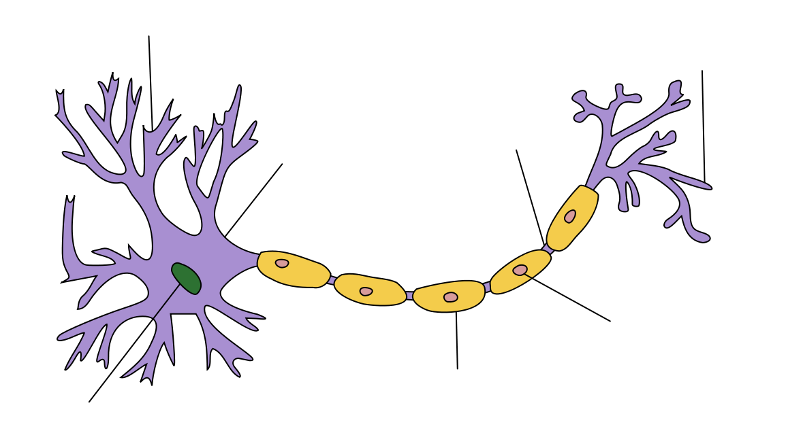

- What is the purpose of the myelin sheath?
__________________________________________________________________________________________________________________________________________________________________________________________________________________________________
- What cell produces the myelin? _________________________________________________

- What is the area between two adjacent neurons called? _________________________________________________
- What chemical molecule is released by the synaptic knobs? ____________________________________________

- Draw a synapse below and label it:

- What are the three types of Neurons?
- _______________________________________
- _______________________________________
- _______________________________________

- What are the two parts of the central nervous system (CNS)
____________________________________________ ____________________________________________
- What are the three parts of the Brain
- __________________________________________________
- __________________________________________________
- __________________________________________________
- What type of response is processed by the spine and not the brain? ___________________________________
- What are the two parts of the PNS
____________________________________________ ____________________________________________

