Name: __________________________________________ Circulatory System Worksheet 2 Heart and Circulation

- Label the following diagram:
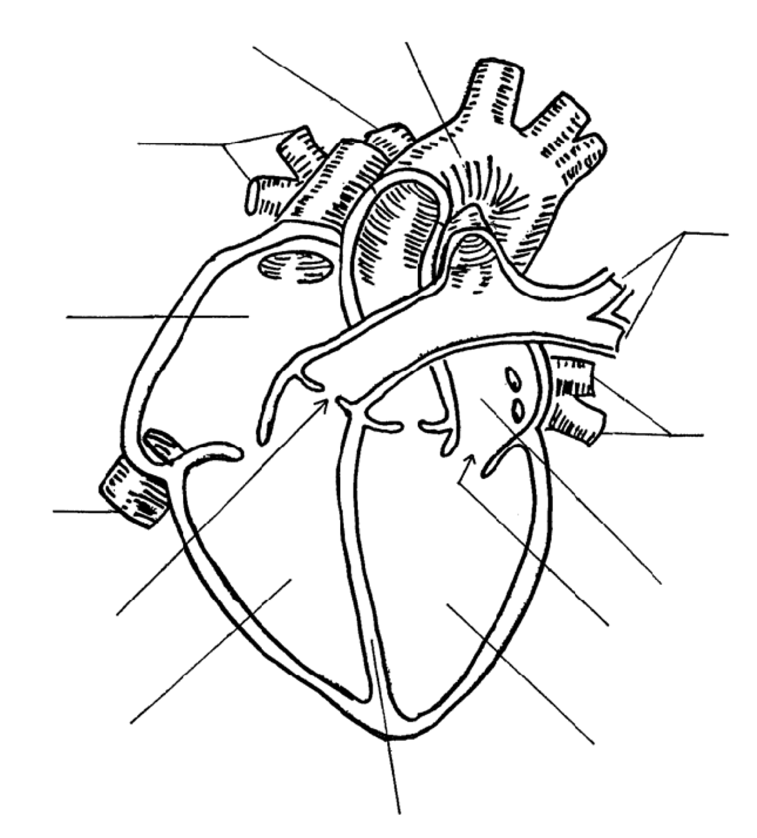

- The Human heart has ___________ chambers and is divided into two sides by the _______________________
- The ____________________________ receive blood from the body and lungs.
- The ____________________________ pump blood away from the heart.
- The _________________ side of the heart contains oxygen poor blood
- The _________________ side of the heart contains oxygen rich blood.
- ________________________ prevent the backflow of blood in the heart.
- The ____________________________ is the major vessel in which oxygen rich blood leaves the heart
- Label the diagram below:
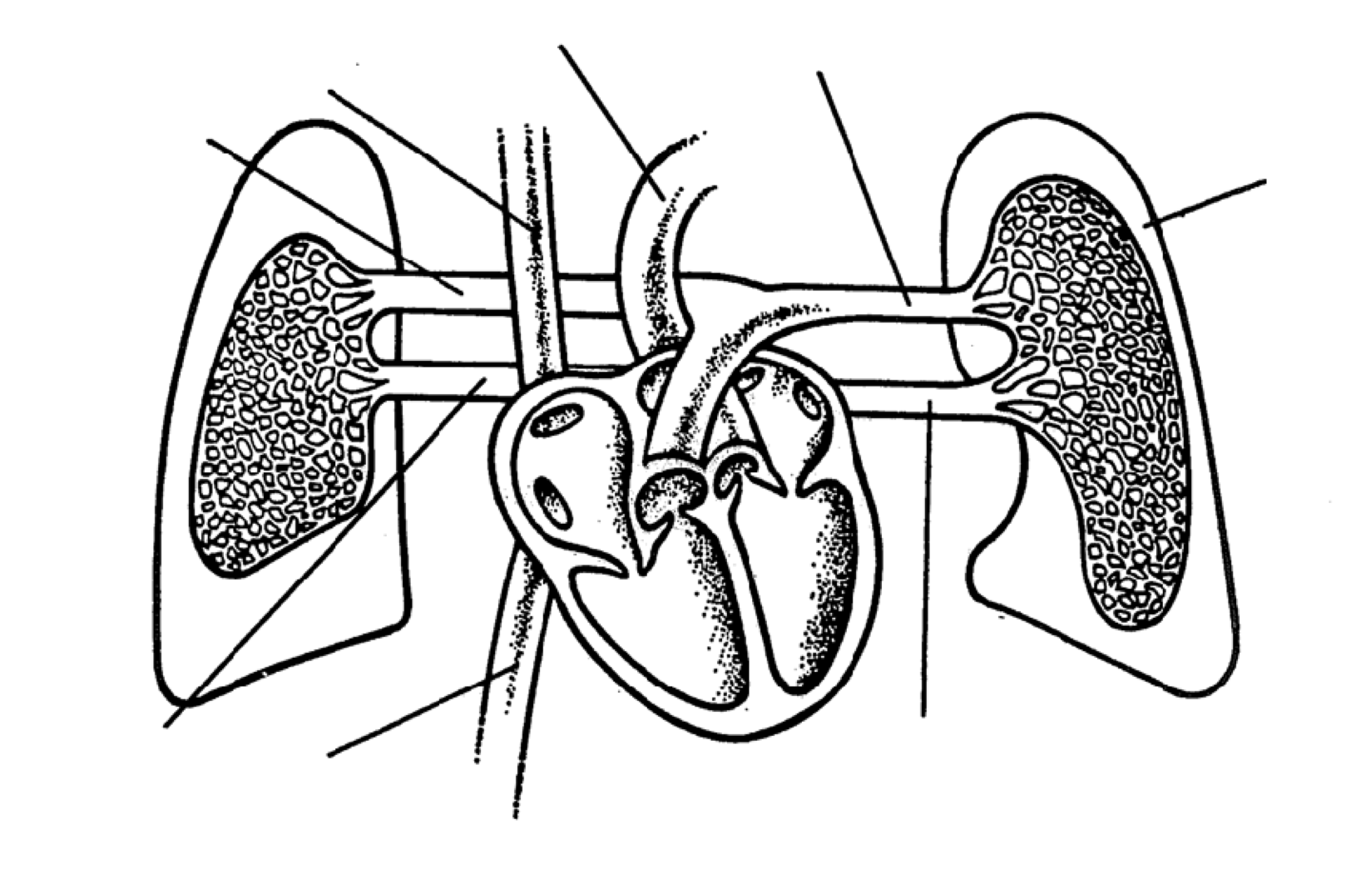

- __________________________________ circulation returns oxygen rich blood to the heart
- __________________________________ circulation returns oxygen poor blood to the heart
- The heart needs its own supply of oxygen in order to function; this is called ________________________ or ______________________________ circulation. When this circulation is blocked a “_____________________ ______________________” occurs.
- Describe how pulmonary circulation differs from systemic circulation in terms of gas exchange.
__________________________________________________________________________________________________________________________________________________________________________________________________________________________________
- If there was a leak/hole in the septum what complications could arise?
__________________________________________________________________________________________________________________________________________________________________________________________________________________________________

