Name: __________________________________________ Circulatory System Worksheet 3
Vessels

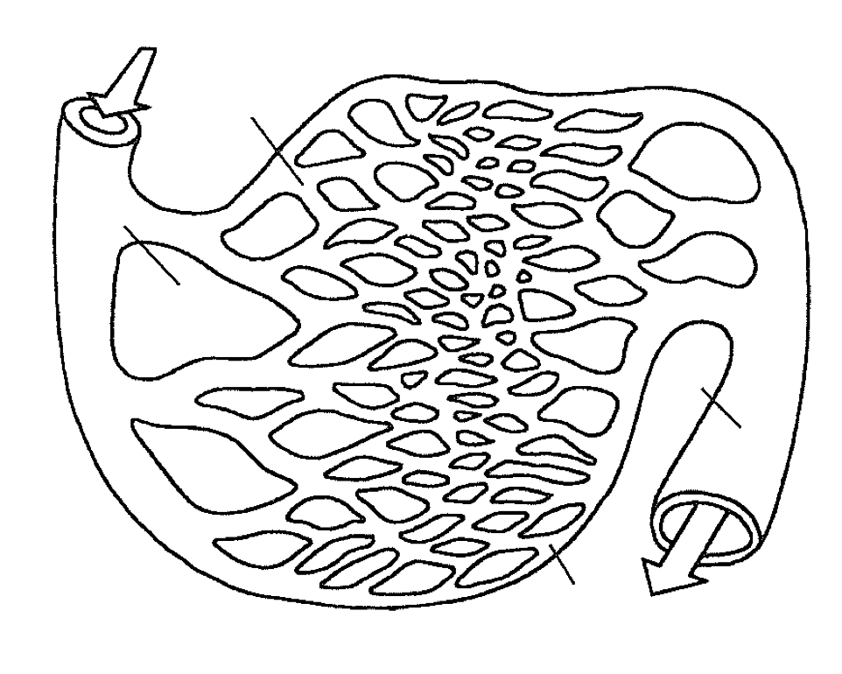

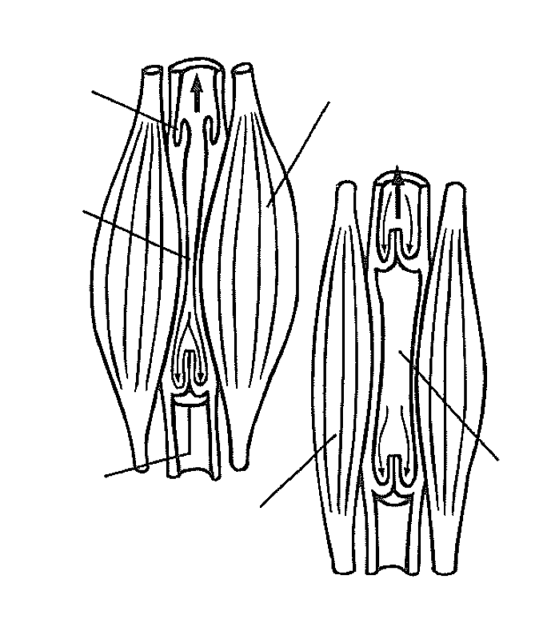

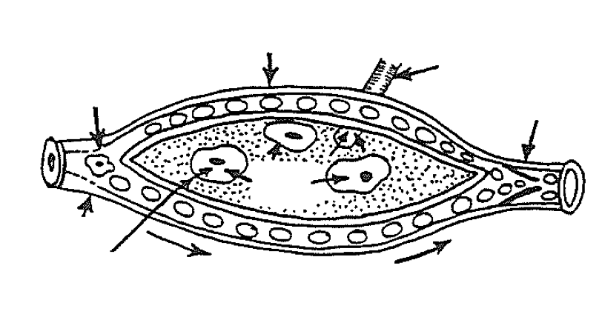

- Describe the structure and function of arteries.
__________________________________________________________________________________________________________________________________________________________________________________________________________________________________
- In the top illustration, why is the color of the blood shown in the veins much darker than the blood shown in the arteries?
__________________________________________________________________________________________________________________________________________________________________________________________________________________________________
- Compare the structure of arteries, veins and capillaries
___________________________________________________________________________________________________________________________________________________________________________________________________________________________________________________________________________________________________________________________________________________
- How does the pressure of blood in the arteries affect the flow of blood from the heart to the tissues?
__________________________________________________________________________________________________________________________________________________________________________________________________________________________________
- How does the pressure of blood in the veins compare with the pressure in the arteries? Because of this, what structure are veins equipped with that arteries are not?
__________________________________________________________________________________________________________________________________________________________________________________________________________________________________
- Study the drawing of the skeletal muscles in the bottom illustration. Describe what happens to the valves in the veins when the skeletal muscles relax or contract.
___________________________________________________________________________________________________________________________________________________________________________________________________________________________________________________________________________________________________________________________________________________

