Name: __________________________________________ Circulatory System Worksheet 4
Blood/Lymph

- What are the four components of blood?

  - ______________________________________
  - ______________________________________
  - ______________________________________
  - ______________________________________

- Where are red blood cells produced? Why must they be produced here and not just replicate themselves?
__________________________________________________________________________________________________________________________________________________________________________________________________________________________________

- What is the function of RBC’s _______________________________________________________________________________
- What role do WBC’s play in the body? _____________________________________________________________________
- What is the function of platelets? ___________________________________________________________________________
- What is the scientific name for RBC ________________________________________________________
- What is the scientific name for WBC ________________________________________________________
- What is the scientific name for platelets ________________________________________________________

- True or false: White blood cells do not leave the blood stream.
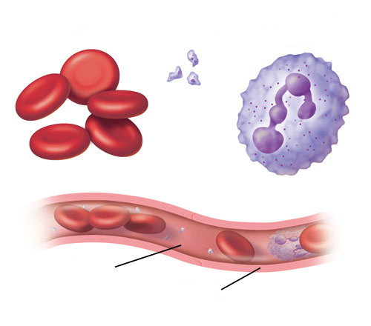
- What are some key differences in identifying RBC and WBC? __________________________________________________________________________________________________________________________________________________________________________________________________________________________________

- Describe how blood clots
__________________________________________________________________________________________________________________________________________________________________________________________________________________________________
- What are the four blood types and what determines what blood type you have?
__________________________________________________________________________________________________________________________________________________________________________________________________________________________________

- The lymphatic system is an ___________________ circulatory system
- Identify and describe the 3 different names given to the fluid found in the lymphatic system.
___________________________________________________________________________________________________________________________________________________________________________________________________________________________________________________________________________________________________________________________________________________
- Describe how lymphatic vessels and veins are the similar
____________________________________________________________________________________________________________
____________________________________________________________________________________________________________
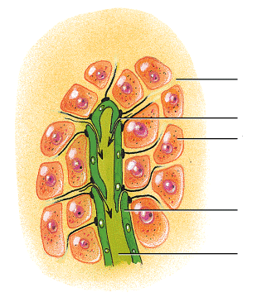
- Label the diagrams below:
